Agency Report:

Rio Salado College and its GED Program at the Communiversity at Surprise

Scott Foster

Colorado State University

EDAE 520

Leann Kaiser, PhD

November 14, 2010

Abstract:

This agency report focuses on Rio Salado College and the grant-funded GED program offered at the college’s Communiversity at Surprise in Surprise, Arizona. To gain insight into this program for the preparation and presentation of this report, I researched background on the college and the program utilizing their website; interviewed Jeff Hall, Instructional Coordinator , Adult Basic Education, Rio Salado College, who manages the program on site; observed a GED class in progress taught by Beverly Ray, an adjunct instructor at the facility; discussed the program and class with Beverly and several of her students; and interviewed Sheryl Hart, Director of Educational Technology and Distance Learning for the Adult Education Services unit of the Arizona Department of Education, which oversees elements of the program at the state level. Sheryl not only helped enlighten me through conversation, but also provided me with some statistical information about Rio Salado College’s ABE program that I’ve included the appendix.
Through this research I learned not only basic information about the program, but also gained an appreciation of the vital service this program performs for the participants and society at large, as well as the current funding challenges that threaten its future existence and the potential implications for the state and its residents should these programs end due to the lack of funding.

Agency Report:

Rio Salado College and its GED Program at the Communiversity at Surprise

My agency report focuses on an institution and educational program which I had little direct knowledge of prior to this assignment. I chose Rio Salado College, part of the Maricopa County Community College system, and specifically focused on the General Educational Development (GED) program offered through the Adult Basic Education (ABE) program at the college’s newest satellite location, the Communiversity at Surprise in Surprise, Arizona where I reside. This report has two main sections: a general agency overview of Rio Salado College and its programs, and a more in-depth program overview of the GED program. I will then address my assessment of both, reflections of what I have learned through this assignment, and my conclusions.
Agency Overview: Rio Salado College

Rio Salado College has been serving the greater Phoenix metropolitan area since 1978. Operating under the motto, “the college within everyone’s reach,” Rio Salado offers a diverse array of educational opportunities both on-line and in-person throughout its twelve satellite locations (Rio Salado College, n.d.). It is the largest of the ten Maricopa Community Colleges in terms of enrollment with an annual budget of $98,287,621 for fiscal year 2010-2011 (Maricopa Community Colleges, 2010).
Rio Salado serves the community’s educational needs in a number of ways including these programs:
- Online learning
- Corporate and government partnerships
- Duel enrollment
- University transfer
- Incarcerated re-entry
- Military and veteran opportunities
- Lifelong learning for seniors
- Adult Basic Education (Rio Salado College, n.d.)
For online learners, Rio Salado offers more than 500 internet based and hybrid classes encompassing programs, certificates and/or degrees in Accounting, Associates in Arts, Behavioral Health/Chemical Dependency, Computer Technology, Creative Writing, Dental Assisting, Dental Hygiene, ten different specialty certifications and degrees in Early Childhood & Human Development, eLearning Design, General Business, Language/Literary Culture of the USA, Law Enforcement Technology, Military Leadership, Organizational Management, Paralegal, Quality Customer Service, Retail Management, Sustainability and Ecological Literacy, Sustainable Food Systems, and seven specialty degrees in Teacher Education. Most of these programs are available without application requirements and are highly flexible and affordable with classes starting every Monday at a cost of $71 per credit (Rio Salado College, n.d.).
Through the Rio Institute for Employee Development, the college partners with local companies, government, and community organizations to provide customized training classes, some of which are eligible for college credits that can then be transferred to a degree program. Offered on a contract basis solely for each company’s employees, the subject content might include business culture, computer applications, customer service, leadership, management, supervision, and customized Spanish instruction among other topics (Rio Salado College, n.d.).
Duel enrollment is a unique program at Rio Salado College that allows qualified high school freshmen, sophomores, juniors and seniors to earn college credit for courses they take while still in high school.
Rio Salado College is the only community college in the state that is nationally accredited by NACEP National Alliance of Concurrent Enrollment Partnerships. (http://www.nacep.org/). With its national accreditation, Rio Salado College Dual Enrollment credits transfer to all Arizona public colleges and universities. Articulation agreements are in place with a variety of colleges outside Arizona. Since Rio Salado College is nationally accredited, many colleges outside the state accept dual enrollment credits (Rio Salado College, n.d., para. 2, Programs, Duel Enrollment, FAQs).

Interested students must apply. Acceptance into the program is based on standardized testing scores. The courses are taught at the high school by faculty members who are community college certified. These classes simultaneously count towards high school and college credits. The program not only gives these students a jump start on their college careers, it provides instruction at a much lower cost than most universities (Rio Salado College, n.d.).
For students seeking an educational path to a four year degree after secondary school, Rio Salado provides core curriculum that is transferable to over 50 public and private universities in state and throughout the nation including Arizona State University, the University of Arizona, Northern Arizona University, the University of Phoenix, DeVry University-Phoenix, Indiana University and Penn State to name a few (Rio Salado College, n.d.).
In addition to serving its traditional student base with classes and programs for credit, Rio Salado College serves the specialized needs of other learners throughout the community. Incarcerated individuals apprise one of those groups. It has partnered with the Arizona Department of Corrections and the Arizona Department of Juvenile Corrections to provide classes designed to help these individuals integrate back into society upon their release. These on-site classes cover skills training in automotive technology, computer technology, construction, furniture, and horticulture. In addition, their Parenting at a Distance program helps female inmates deal with the separation and eventual reintegration with their kids (Rio Salado College, n.d.).
For active duty military personnel and veterans, Rio Salado College offers both certificate and degree programs in Military Leadership. The college provides other learning programs and student services specifically geared towards assisting those on active duty and those returning to civilian life. “Rio Salado has been recognized by G.I. Jobs Magazine as a ‘military friendly school’” (Rio Salado College, n.d. para. 1, Military).
The college promotes lifelong informal learning for senior citizens in the community by hosting RISE Learning for Life at its Surprise Lifelong Learning Center. RISE originally stood for Rio Institute for Senior Education, but the organization has now dropped the full title. RISE is a separate, grassroots community based organization open to all seniors in Maricopa County. For an annual fee, its members may attend classes ranging from history to the arts to current affairs and more (Rio Salado College, n.d.).
Lastly, Rio Salado provides ABE and English as a Second Language (ESL) classes for those who have never earned a high school diploma and/or those in need of basic English language skills. These courses are offered free to participants through federal grants. For my agency visit, I chose to focus on GED classes offered at Rio Salado College via its Communiversity at Surprise.
Program Overview: GED Classes at the Communiversity at Surprise
I recently met with Jeff Hall, Instructional Coordinator for Adult Basic Education at Rio Salado College’s Communiversity at Surprise, one of several Rio Salado College satellite locations scattered across the Phoenix area. Hall explained to me that their facility handles three main functions. First, it’s a college center offering advisement, counseling, testing, a computer lab, and some credit courses. Second, it hosts classes offered through the RISE Learning for Life program available to local seniors. Lastly, it conducts Adult Basic Education in the form of grant-funded GED and English Language Acquisition for Adults (ELAA) programs offered free to legal residents on a first come first served, space available basis (J. Hall, personal communication October 18, 2010). Jeff is in charge of managing these ABE programs. We spent an hour discussing the ABE program.
The Program
Rio Salado College’s ABE program is the largest in the state and offered at several of its facilities. GED and ELAA programs have been offered at the Surprise location for the last five years, with approximately 300 students participating in the last year. Currently, 13 of these classes are being offered at the facility taught by eight instructors. Students must be at least 16 years of age and be able to provide proof of citizenship. These are the only prerequisites for participation. To get started, students need only to call the facility and get set up to attend an Orientation. However, space is limited and there is currently more demand than there is capacity. Every student’s situation is different as Hall elaborated:
During Orientation, they just need to show up. They do have to show proof of legal residency. Once they show that, we get them into our program. During Orientation, they are tested to see where they’re at. From that we set some goals and monitor their progress (J. Hall, personal communication, October 18, 2010).

Following the orientation, students are classified and placed as a baseline into one of six skill levels based on their test scores. These levels are defined by the state of Arizona Department of Education and developed by field educators within the state. For GED students, these skill levels range from ABE Beginning Literacy for those students who completely lack literacy skills to Adult Secondary Education (ASE) High for those GED students performing closest to the level required to earn their GED. Although classified at the various levels, all GED students go through the program in a classroom setting that includes students from all levels. Class curriculum emphasizes reading; math, which depending on the student can include everything from basic arithmetic to algebra and geometry; language including grammar and writing skills; science, technology, and civics – all of which are taught in the same class, same class session, with the same instructor. Students are tested in these areas after about every 60 hours of instruction and advanced through the program based on that testing performance. For each student, classes are self-paced. “When students come into the program, there’s basically no time limit. I have one student on her third year and 106 students in their second year. Likely, the average time is five to six months” (J. Hall, personal communication, October 18, 2010).
The goal of the GED program is for every student to stay with the program and eventually earn their GED. However, it doesn’t stop there.
We spend a lot of effort trying to recruit and motivate and help GED students to own and pursue their education. The GED is just a stepping stone. In today’s job market, the GED is not sufficient. People need to have some kind of postsecondary education, whether that’s college or a trade school to help them get jobs. We have students cross over from GED to higher programs. We foster that. We have a candidate assistance program where we have academic advisors that help guide students through that process as well as scholarships (J. Hall, personal communication, October 18, 2010).

Due to the recent downturn in the national and local economy, Jeff has seen a greater sense of urgency on the part of students recognizing the need to get their GED and go beyond.
The whole economy has changed everybody. Three years ago, it used to be, students would come in and want their GED so that they could get a better job. Then it changed to they come in so they can get a job. Now, “I need this to keep my job.” A lot of employers are cutting back. This person has a GED. This person has a high school diploma. They have to get rid of someone (J. Hall, personal communication, October 18, 2010).

The Learners
As previously mentioned, the GED students in the ABE program must be at least 16 years of age and legal residents. For a variety of reasons, each lacks a high school diploma. Beyond these common elements, they are a diverse group in terms of age, race, sex, and social and employment status. Although demographic data on the participants is gathered for statistical purpose, Hall explained, “We don’t ask people what their background is” (J. Hall, personal communication, October 18, 2010). Although every student is different, they all have reasons why they never graduated. Most are motivated to succeed, but some require a reality check to be successful in the program. As Hall explained the school takes these factors into consideration:
It’s not just about education. It’s helping students overcome some of the obstacles that kept them from being successful in high school. Even though they’re older, many still deal with some of those issues. We try to be a good role model and instill some of the characteristics that will help them be successful – responsibility, perseverance. It’s not just academics. Sometimes students will come in with the save behavior traits they had in high school. Even though they are ten years older, they still have issues. (We) try to make them realize how important this is and they will have to apply themselves. Some students think they can just come in, sit in class for a few weeks, and not have to do a whole lot to pass (J. Hall, personal communication, October 18, 2010).

During my visit to the Communiversity at Surprise, I was given the opportunity sit in on a GED class taught by Beverly Ray in progress and was able to chat with the group. I asked them why they were there, how they liked participating in the program, and how the program differed from their past classroom experiences. Although I wasn’t able to talk to them on an individual basis or at great length, the responses I got were all positive. I only asked them to give their first names.
One student, Andrew said, “We’re here to get a better education.”
Another student, Amber, added, “We like it because we want to be here – not because we have to be here.”
And another, John added, “It’s convenient. We only have to go to one class to get the whole thing done.”
The group I observed seemed to be enjoying the class. The atmosphere was light and informal, and the students seemed to be genuinely engaged in the conversation but also able to joke a little in the process. When I asked what they liked best about the program, Andrew responded smiling, “Ms. Ray”, which brought a chuckle throughout the class including Ray. As they reviewed some science terminology as a group, other students as well as Ray frequently injected humor into the discussion. I didn’t see any students who looked like they did not want to be there. As a group, their attitude was consistently positive.
The Instructors and Instructional Methods Utilized
Hall and I discussed the instructors and instructional methods of the GED program at some length. The state requires that Adult Education instructors have a bachelor degree and an Adult Education Certificate issued by the state following a fingerprint and background check. Just as the student make up of the program is characterized by diversity, so are the instructors, their backgrounds, and their teaching methods. While the state dictates standards of the program and periodically updates those standards, how the material is taught is totally up to the individual instructor. The diversity of student needs requires unique creativity and flexibility on the part of the instructors.
A GED instructor is probably one of the best instructors you will ever find because it is a fluid environment. You really have to focus on individualized instruction. It is more of an art form. There’s some lecture. There’s some individual work. There’s some group work. What happens in a typical GED classroom is you have basically three primary areas of study going on – reading, math… and language… All three are typically being taught in the average classroom to a group of students with all different abilities. Each GED classroom is different and each day is different. How a teacher does that is what makes it sort of an art form (J. Hall, personal communication, October 18, 2010).

Each instructor has a different background and motivation for teaching in the program. The typical instructor has another job, although an increasing number teach the program full time, despite the limited full time opportunities. Many are educators or former educators, but many are not. Hall elaborated:
I’ve had people who were substitute teachers all the way up to retired school administrators teach classes. Right now, I have a couple retired teachers, a person who’s worked 30 years at American Express and been teaching for 18 years part time. In some ways, I think that our Adult Education instructors that do not have an educational background are sometimes more successful with their students, because they bring their real world experiences with them. I have an executive director of a corporation that teaches for us. He doesn’t need to do this. He doesn’t need the money. He just wants to do this as a way to give back to the community (J. Hall, personal communication, October 18, 2010).

Ray, whose class I observed is a prime example. I was able to chat with her briefly. She teaches in the GED program part time when not working as a Realtor, principally because she enjoys it. She has an MBA and previously worked in Health Care Management. Her passion for teaching was plainly evident during my class observations. As mentioned previously, she promoted a relaxed atmosphere that fostered a strong rapport with the students and a sense of comfort at an interpersonal level. While maintaining a focus on the subject matter, she recognized the need and allowed the students to occasionally interject opinions and observations that were linked to but slightly divergent from the subject matter. She did a great job of communicating on the student’s level and promoted dialogue. It was not a lecture format, but more conversational in nature. I that feel this really engaged her students.
As I observed the class in progress, I thought about Hall’s comments regarding the unique nature and diversity of the students and teaching styles required for a GED class. The flow of the class was very fluid. When I first entered the room, the class was finishing up an open book history test. Everyone was participating and doing the same test. The class then switched gears and transitioned into a review of previous science assignment, genetics terminology. The textbooks were distributed and each class member took turns providing answers to the exercise. Again, the entire group participated.
When that exercise was completed, there was still over an hour left in the class session. Ray gave the group the choice of working on math next, or discussing relationships, a topic they had started to address the previous day. Although not part of the official curriculum, understanding how people get along with another is very much a real world skill. Even though they ended up working on the math lesson, I thought by presenting the elements of choice and the option to address real world situational people skills as part of the class activity, Ray not only fostered a spirit of participatory learning, but reinforced student confidence and empowerment providing a positive mindset they can carry with them inside and outside of the classroom. They were being encouraged to exercise their judgment to affect a learning outcome, and not just assigned an agenda from an authority figure. This strategy encourages each to be proactive and self-directing in a positive way. Just as Hall has said, for Ray and her for her students, it’s not just about education.
I stayed for a few more minutes as they again switched gears to math. For this subject, the focus was much more individualized. Different textbooks were handed out corresponding to student’s varying skill levels. For this part of the class, Ray worked with each student individually. Once again, both instructor and class moved seamlessly from the previous subject to the next despite the change in teaching methods. It demonstrated the versatile nature of the program and the teacher necessitated by its limited resources.
As I concluded my visit and thanked the class, I reflected on what I’d experienced. My first hand observations very much validated Hall’s previous characterizations of the program, its students, instructors and teaching methods. I also acquired an enhanced appreciation of the program and the benefits to its stakeholders - the individual student, the college, and society. Unfortunately, as I later learned, the future of the program is in jeopardy.
Funding, Program Evaluation and the Future
To conclude my research for this paper, I met with Sheryl Hart, Director of Educational Technology and Distance Learning for the Adult Education Services unit of the Arizona Department of Education. Hart’s department oversees elements of the state ABE programs, including the GED program in Surprise. She and I discussed Rio Salado College’s ABE program’s funding and its evaluation, as well as its future.
As Hart explained, due to the nature of the Adult Basic Education programs offered through Arizona’s public institutions, including Rio Salado College, funding for the program and evaluation of the program are tied together and both are tied to its future. ABE programs including the GED programs there and throughout the state education system are completely reliant on direct and indirect government funding. The State of Arizona is currently in the midst of an unprecedented financial crisis and the current state budget allocation for Adult Education is $0. Consequently, these programs are currently reliant primarily on grants from the federal government. The federal funding of these grants is contingent upon a 25% match, which can be in the form of dollars or in-kind contributions such as donated classroom space, supplies, etc. This money flows from the U.S. Government Department of Education to the Arizona Department of Education, which then allocates the funds to the various programs, including the GED program at Rio Salado (S. Hart, personal communication, November 11, 2010).
For the current year, the total budget for all the Adult Basic Education programs including Rio Salado’s GED program is $2,749, 342. The federal grant portion of that budget is $2,521,842 (S. Hart, personal communication, November 11, 2010). With no state money allocated in the current budget, the difference is made up through “backfilling.” The institutions that receive this money, such as Rio Salado College, have agreed on a short term basis to backfill, or make up the difference with other monies they’ve received through the federal stimulus programs. This agreement between the state Department of Education and those institutions keeps these programs alive for now.
Funding for Arizona’s ABE programs is also directly tied to its performance. Each year, a multitude of performance and demographic data is gathered and the results are measured and reported to the state, which forwards the information to the federal government. Rules regarding how performance data is collected and interpreted are defined by the National Reporting System (NRS), a division of the Office of Vocational and Adult Education (OVAE), which is part of the U.S. Department of Education (DOE). Test scores and educational gains within the program along with student academic and employment goal outcome information are some of the key measurements in the process (S. Hart, personal communication, November 11, 2010). Complete details are available at the NRS website, www.nrsweb.org. Future funding is based on these results and meeting minimum standards. Sheryl provided some statistical data on Rio Salado College’s program outcomes including the programs held in Surprise (see Appendix ). I was unable to obtain data specific to the GED classes at Surprise.
The backfill agreement negotiated between the State Department of Education and the various learning institutions is in effect for the next two years. Beyond that, ABE programs including the GED program at Rio Salado College are in jeopardy if the State doesn’t restore funding to the budget. The loss of these programs would create an educational void with far reaching implications. Statistically, one in five high school diplomas issued in Arizona in any given year are High School Equivalency Diplomas earned through GED testing (S. Hart, personal communication, November 12, 2010). Without this resource, people like those I met in Beverly Ray’s class would be less employable, less productive, and certainly more reliant on social programs to survive, with the taxpayer footing the bill. Furthermore, this legacy is often passed to their children as Hart points out, “If the parent can’t read, do math or speak English, it will negatively impact the kids’ performance in school. Adult Education helps people get better jobs and it also has a very positive impact on the entire family” (S. Hart, personal communication, November 12, 2010). On a human level, this would be tragic; on an economic level, self-defeating.
Assessment of Program, Lessons Learned, Concluding Remarks,
This assignment has been very much a mission of discovery and afforded me the opportunity to learn much about Rio Salado College, its grant based GED program, and the intricacies of ABE as an important branch of Adult Education. I knew that the college existed, but was largely unaware of its varied programs. I had no knowledge that the Surprise facility existed, although I’ve resided there for seven years. As I explored the various pages of the college’s website I was struck by its value as an institution, the value of its educational offerings, and its value to Maricopa County. As we have discussed extensively in class, community colleges are potentially our greatest educational resource as strive to address the societal, social, and economic challenges we face due to globalization and the emergence of the knowledge economy. By all rights, Rio Salado College serves as a model for that vision.
Especially enlightening to me personally, the conversations and research I conducted have given me a first-hand perspective of the subfield of ABE that I previously lacked. As I process the information I have gathered and critically reflect on the program, several lessons stand out – the effectiveness of the Rio Salado College GED program given its limited resources, relative anonymity in the public’s eye, and precarious future; the dedication of its educators and a deeper appreciation of their unique skills, improvisational abilities, and passion to make a difference; and an enhanced validation of our previous class discussion themes concerning the real world tie-in of ABE, social justice, social power, and the ability and/or lack thereof to influence governmental policies having far-reaching implications on a societal level.
The GED program in Surprise is successful, despite a host of obstacles. It has to be, or it would have eliminated by now for not meeting the required standards. As a part of the overall Arizona GED programs, it contributes a high percentage of the yearly output of secondary education graduates in the state who would otherwise lack the educational opportunity to better their lives.
The program is successful despite operating under conditions that are far from ideal.
We have to do more with less. Compared to elementary school programs with the same number of students, AE lacks the amount of support staff. The state of Arizona spends $6500 a year for each elementary school student. It spends $200 a year for each Adult Ed student (S. Hart, personal communication, November 11, 2010).

The program is successful despite a lack of publicity or awareness. While the state’s budget crisis and its implications for Arizona’s education system have been extensively covered by the local media, little or no attention is being given to the state’s adult education crisis. Even in better economic times, ABE is given little attention. As we’ve previously studied in class, the benefactors of ABE tend to be the poor; the minorities; the socio-economically disadvantaged; the transparent who lack a political voice, existing in the margin of society.
The program is successful despite the uncertainty it faces. For its immediate stakeholders, keeping focus and maintaining forward progress has got to be challenging when it’s uncertain whether the program will even exist long enough for the students to finish. There are no easy answers to the state’s monetary woes and no guarantee that a viable solution is forthcoming, yet the students, the administrators, and the instructors persevere.
This experience has taught me that those instructors and other behind the scenes participants contributing to the ABE program represent a very special, unheralded breed of educator. As Jeff elaborated, although not a lucrative career in terms of money, they pay off is there for these people. “Adult Education is rewarding. The pay is not, but you do see the results of your efforts. You do see people excel. You do see people learning English; learning to read; learning to communicate” (J. Hall, personal communication, October 18, 2010).
In class, we’ve talked about the inherent diversity within Adult Education and the need to be able to individualize instruction to meet the unique needs of each student. Through my observations in Ray’s class, I now have a better understanding of how that can be accomplished. I’ve had to teach programs and classes to groups with varying skill levels and know how difficult it is to engage everyone. The GED class I sat in on demonstrated that it can be done effectively and Ray demonstrated that flexibility and adaptability must be adapted as a teaching strategy in that environment. She was very effective and a true model for her students and other adult educators. On a personal level, the experience has inspired me to consider playing a role myself in ABE professionally. There could be a career opportunity within the program at Surprise in the near future and I’ve expressed my interest for consideration.
Lastly, the assignment brought me a new awareness of the underlying benefits ABE brings to society, the role of ABE as a facilitating force in the promotion of social justice, and the frustrations felt by those involved in ABE to garner the political support that is vital to their cause. Having taught in the past exclusively within the area of workforce education, these issues never really entered into the equation or touched me personally. I now have a new perspective.
ABE programs like Rio Salado College’s GED classes at Surprise are vital. They serve both the individuals who utilize them and society as a whole. These programs must continue or we all will pay a heavy price. Given the current economic and political climate in Arizona, the challenges are great. The recent state elections have not only reinstated many of the legislators who have historically ignored the educational needs of the state, they have gained greater power. As future budgets are scrutinized in their crafting, these leaders should and must understand that Adult Education is more than a line item; it is more than rhetoric; it is more than politics. Adult Education should and must be a priority moving forward for the general good of the state and its residents.

Acknowledgements
I would like to sincerely thank the following individuals for their assistance with this assignment:

Sheryl Hart
Director of Educational Technology and Distance Learning, Adult Education Service
Arizona Department of Education

Lily Beth Brazones, M.Ed., CMPI
Director, Continue Education, Adult Basic Education
Rio Salado College

Jeff Hall, M.S., CMPI
Instructional Coordinator, Adult Basic Education
Rio Salado College

Beverly Ray, MBA
GED Instructor
Rio Salado College

The students of Ms. Ray’s GED Class
Rio Salado College

Appendix
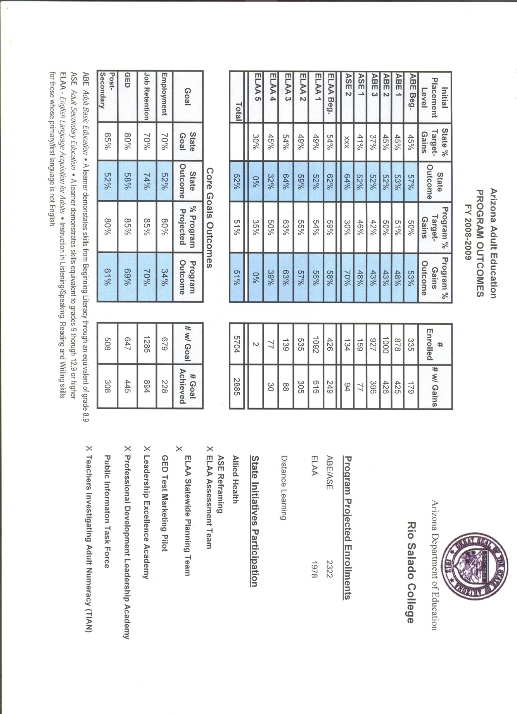
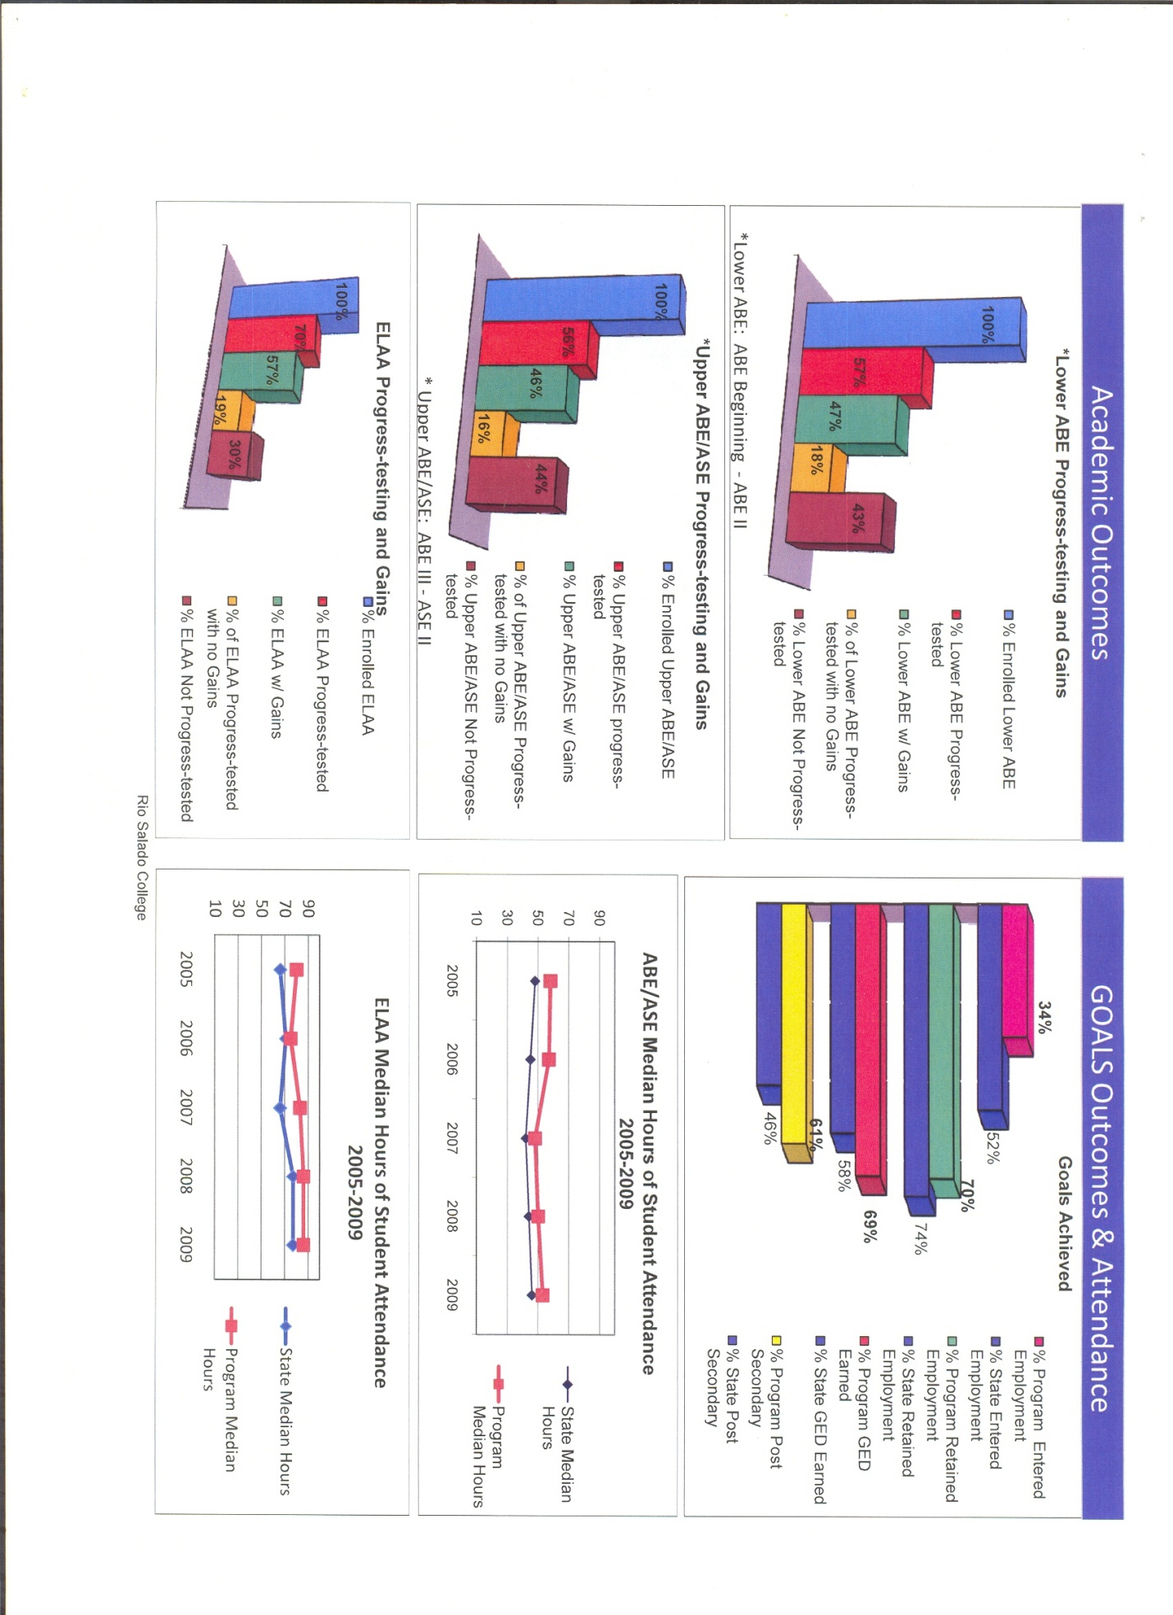
Source: Arizona Department of Education
References
Maricopa Community Colleges, 2010, Adopted Budget FY2010-2011, pg B4, retrieved November 11, 2010 from http://www.maricopa.edu/business/budget/fy11bgt/FY11Adoptbgt.pdf

Rio Salado College, n.d., retrieved October 18, 2010 from http://www.riosalado.edu/Pages/default.aspx

Rio Salado College, n.d., para. 1, Military, retrieved from http://www.riosalado.edu/military/Pages/default.aspx

Rio Salado College, n.d., para. 2, Programs, Duel Enrollment, FAQs, retrieved October 18, 2010 from http://www.riosalado.edu/programs/dual/Pages/faq.aspx

