Instructor’s Manual
Basic Computer Skills Course

Presented by the Valley Christian Center
Scott Foster, Course Designer

Basic Computer Skills Course
Table of Contents

Introduction………………………………………………………………………….Page 4
Session #1 Lesson Plan……………………………………………………………...Page 8
Session #2 Lesson Plan………………………………………………………………Page 11
Session #3 Lesson Plan………………………………………………………………Page 13
Appendix A – Needs Assessment……………………………………………………Page 14
Appendix B – Audience Analysis……………………………………………………Page 18
Appendix C – Learning Assessments………………………………………………..Page 25
Appendix D – Content Outline………………………………………………………Page 30
Appendix E – Formative and Summative Evaluations………………………………Page 34

Introduction:
Background and Methodology

Background

It is my pleasure to present this Instructor’s Manual for Basic Computer Skills for Job Seekers at the Valley Christian Center, the end result of a project that was developed utilizing instructional design methodologies. This course was created to meet three primary goals:
- To fulfill the course requirements for the designer’s master degree program.
- To fill an educational gap that currently exists for job seekers of low socio-economic status utilizing employment skills training resources provided by a consortium of charity-based organizations in the South Phoenix area. A number of free classes are currently being offered through a partnership of the Maricopa Skills Center, The United Way, and other charity organizations, but none are adequately addressing the basic computer skills needed to apply for employment online.
- To help the Valley Christian Center promote its computer lab, an under-utilized resource at the Center. The Valley Christian Center (VCC) is a 90 + year faith-based charity organization which has fallen on hard times financially. The VCC is currently undergoing a revitalization campaign under the leadership of its new Executive Director, Rebecca Castro. Castro is seeking ways to draw new investors and charitable contributions to fund the VCC’s many programs by demonstrating that the Center provides unique value and opportunity to the community and its followers. By demonstrating greater utilization of their computer lab, the VCC can hopefully enhance its fundraising efforts.
In order to gain an understanding of the process that created this course and this manual, I would like to present a synopsis of the instructional design methodology employed.
Methodology
The instructional design process employed to create this course began with a Needs Assessment (see Appendix A). This is the starting point for developing any kind of instructional program. As the name implies, this step asks the question, “Is there an instructional need to be fulfilled?” To answer that question I interviewed Castro and Daniel Adonis, Career Services Coordinator at the Maricopa Skills Center (MSC). Through these discussions, I learned that the VCC participates with MCS and other charity-based organizations in a host of free employment resource training. However, none of the current programs adequately address the basic computer skills needed to apply for employment online, which is the most popular and often the only way to apply for employment in today’s job market. Based on my findings, it appeared that there was a need for course addressing these skills. To further test this hypothesis and to determine if such a course would be utilized if created, I proceeded to the next step in the instructional design process, the Audience Analysis.
The Audience Analysis (Appendix B) was used to gain further insights into whether the perceived educational need is real by going to the source – the audience who would be participating in the course if the course were to be offered. To accomplish this, I constructed a questionnaire to analyze the target audience, identify their level of motivation to attend such a class, their current knowledge of computers, and make key determinations about the content and approach when designing the instruction. The questionnaire was left on display at the VCC and distributed during their regular Wednesday food basket distributions. Although the response was limited, there was enough evidence presented from the results of the questionnaire to proceed with the project.
From this point forward in the instructional design methodology, several steps were developed more or less simultaneously with each influencing the others. The process was more holistic than linear and included the creation of Learning Objectives, Learning Assessments, a Content Outline, and Evaluation Plans. As each of these components was developed, the others could be and were modified accordingly.
The learning objectives created for this course are as follows:
At the conclusion of this course, the participants should be able to:
- Identify and explain key MS Windows-based computer terminology and functions used when conducting an online employment search.
- Demonstrate the correct application of those computer functions to integrate internet based resources and methods into their job search.
- Utilize email in their job search.
- Apply MS Word software to create documents used in job searches such as resumes, cover letters, employment history data sheets, and follow up correspondence.
- Access, modify, and save electronic copies of their job search documents on a portable flash drive.
In developing these learning objectives, accompanying assessments were also developed to measure how successfully the instruction meets those objectives. See Appendix C for the list of those assessments and rationale for each assessment.
The next step in the process, the Content Outline (Appendix D) was formulated as a guideline for developing the course. Accompanying that Course Outline is the Course Syllabus (Attachment # 1).
Lastly, the Formative Evaluation and Summative Evaluation (Appendix E) were developed as tools to be used for fine tuning the course by getting feedback from the course stakeholders throughout the development process, during the actual instruction, and following the instruction. Instructional Design Methodology by nature is ongoing even after a course has been developed and presented as feedback triggers modifications to future courses which, in turn, receive feedback which often spawns additional modifications. The process continues as long as the course is offered.
The Instructor’s Manual that follows is the primary end product resulting from the instructional design process employed for this project. It is my hope that the learning which it produces will better the lives of those who participate by better equipping them to find employment using online resources and methods.
Scott Foster
Instructional Designer

Basic Computer Skills Course

Session # 1 Lesson Plan – Basic Computer Literacy

Introduction

- Begin with a discussion about the current economy and especially the high unemployment numbers. Ask the group about their own employment situations and how long they have been looking for work. Discuss their recent job hunting experiences.
- Discuss the ways people have historically looked for employment – newspaper want ads, “pounding the pavement”, applying in person, filling out paper job applications. Then discuss the ways this process has now changed, principally the practice of applying for jobs via the internet and electronic mail. Discuss how most job applications are now completed on line exclusively and resumes are now most often transmitted by job seekers and gathered by organizations looking to hire via email.
- Hand out hard copies of the course syllabus (Attachment #1). Discuss the syllabus and learning objectives and describe how the course will approach the subject matter being taught and how the students may benefit from attending he course.
- Questions & Answers.
Learning Activity #1
- Discuss Learning Objective # 1: At the conclusion of this course, the participants will be able to identify and explain key MS Windows-based computer terminology and functions used when conducting an online search. Reiterate not only the objective, but discuss the planned learning activity, and the assessment that will be completed at the conclusion of the session. Start the session with the student’s computers off.
- Hand out hard copies of the Learning Session #1 PowerPoint presentation, Basic Computer Skills Part 1, Basic Computer Literacy (Attachment # 2).
- Load PowerPoint presentation onto the projection computer for the class to view and execute the presentation. As the presentation progresses, take time to restate the meanings and function of each term providing alternative language and frequently ask relevant questions.
- At the conclusion of the PowerPoint, using the projector and mouse pointer, review the different terms, their location on the computer screen, and their functions. Pull up the internet browser and discuss those relative terms also.
Learning Activity # 2
- Discuss Learning Objective # 2: At the conclusion of the course, the participants should be able to demonstrate the correct application of those computer functions used to integrate internet based resources into their job search. Discuss the planned learning activity and the assessment that will be given at the conclusion of class.
- Explain the correct procedure for turning on the computer. Ask the class to turn their computers on.
- After the computers are on, give the class 5-10 minutes to use their computer mouse to explore the compute and ask questions. Go around the lab and work on an individual basis with the students as needed.
- Review the procedure for gaining access to the internet and using a search engine. Give them a site to find and ask them to go to that site. Repeat the procedure for a couple of other random websites asking the class for sites they’d like to explore. Give them 10-15 minutes to explore using the internet.
- Together as a group, access job boards at www.indeed.com, www.careerbuilder.com, and www.jobing.com. Demonstrate how to use the job search functions at each site.
- Ask the class to name an employer then would like to explore, then lead the class to their website and job application screen. Repeat the process for 2-3 other employers.
- Demonstrate the correct procedures for shutting down the computer on the projector computer and have the class follow along shutting down their own computers as well.
- Questions & Answers.
Learning Activity #3
- Discuss Learning Objective # 3 – At the conclusion of the course, the participants should be able to utilize email in their job search.
- Using the project computer, the instructor will lead the class to www.google.com and demonstrate creating an email account at gmail.com. Each student will create an account following the instructions on the screen.
- After each student creates an account, the instructor will post the email addresses they created. The Students will then write an email to the other students.
- Instructor will demonstrate how to attach other documents to the email.
- Questions & Answers.
Assessment
At the conclusion of Learning Activity #3, the instructor will handout the Assessments for Learning Activities #1, #2, and #3 (see Attachment #3). Student’s will then complete the assessment.
Following the completion of the assessment, students will complete and hand in the Formative Evaluation (Attachment #4). This will conclude the first session
Session #2 Lesson Plan – Creating and Storing MS Word Documents
Introduction
- Prior to the start of this session, the instructor will recap highlights of the information covered in the previous lesson, and ask the students if there are any questions or comments from the first session.
- The instructor will then provide an overview of the material to be covered in Session #2, creating MS Word documents for the job search and using a USB drive to save their data.
- Questions & Answers.
Learning Activity #1
- Discuss Learning Objective # 4 – At the conclusion of the course the participants will be able to apply MS Word software to create documents used in job searches such as resumes, cover letters, employment history data sheets, and follow up correspondence.
- Instructor will hand out hard copies of the Learning Session #2 PowerPoint presentation, Basic Computer Skills Part 2, MS Word for Job Seekers (Attachment # 5).
- Instructor will show the PowerPoint covering some of the basic features of Word used in resumes and letters.
- Students will then open M.S. Word on their computers and be given 5-10 minutes to play with the various features covered.
- Instructor will then hand out Employment History Data Sheet Handout (Attachment #6), and Resume Template (Attachment #7) and discuss the handouts.
- Students will then be asked to create their own electronic versions of both documents. Ample time should be given to this task – approximately one hour. Instructor will go around the lab and work with students on an individual basis.
- Questions & Answers.
Learning Activity #2
- Discuss Learning Objective # 4 – At the conclusion of this course, the participants should be able to access, modify, and save electronic copies of their job search documents on a portable flash drive.
- Instructor will demonstrate the correct way to use a portable flash drive then ask the students to save their documents onto their own flash drives.
Assessment
As an assessment for Learning Activity #1, ask the students send the instructor an email attaching electronic copies of their employment data history documents and resumes. For Learning Activity #2, save their documents to their flash drives, then present the flash drives to the instructor who will then install the drives on the instructor’s computer for review.
Following the assessments, the students will be asked to complete another Formative Evaluation (Attachment #4).

Session #3 Lesson Plan – Review and Individual Instruction
- No new material will be covered in Session #3. The time will be used to work with students on an individual basis on any of the material previously covered or assisting them with the completion of online job applications, their data sheets, resumes or letters.
- At the conclusion of the course, the students will be asked to fill out the Summative Evaluation (Attachment #8)

Appendix A – Needs Assessment

Background

The Valley Christian Center (VCC) is a faith-based charity organization that has served its surrounding community for more than 90 years. That community is part of the greater area known as South Phoenix, which is characterized by a population consisting of minorities of low socioeconomic status with little higher education and high levels of unemployment. I became aware of the VCC through a charity project I was involved in back in 2008, and subsequently provided their staff members with free customer service training soon afterwards as a way of helping them with their mission. Although I’d fallen out of touch with management at the VCC the last several years, I decided to approach the organization to see if they had any current training needs, either internally or for their customers, that I might be able to provide that would help their organization and/or their customers, and also help me fulfill the requirements EDAE 629.
I paid a visit to their location and discovered that much had changed since the last time I’d had contact with them. The management team that I’d previously worked with was no longer there, and the VCC had lost most of their funding sources as a result of the mismanagement of the past. After introducing myself and the purpose of my visit, I had a discussion with Rebecca Castro, the current Executive Director at the VCC. As Castro explained, the VCC has provided a variety of services over the years, but due to recent funding issues, is currently primarily focused on food distribution, and only on a limited basis when compared with the past. However, she wants to change that, make the VCC more viable again as a functioning charitable organization, and find ways to provide other services to their community members as well, including assistance with employment and job hunting. She further explained that the VCC, United Way, and several other local charity organizations in the South Phoenix area are currently working in partnership with the Maricopa Skill Center (MSC), a division of Gateway Community College providing career and vocational training, and free seminars for job hunters.
The Need
We then discussed possible gaps or needs in their career training. She mentioned to me that at a recent meeting she attended with the MSC career training partnership leadership, a relevant training need had been discussed – basic computer training for job seekers. The job hunter of today must have as a bare minimum some basic computer skills just to apply for jobs. Many in that community lack that basic training and many do not have access to computers. Although the VCC is not currently hosting any of the free training events that the partnership provides, Castro has created a computer lab at the VCC, currently un-utilized, that could accommodate such training. She suggested that I discuss the idea at greater length with Daniel Adonis, Career Services Coordinator for MSC. Adonis heads up the free career and job hunting seminars for the partnership of charities and coordinates the different events they sponsor.
Following my meeting with Castro at the VCC, I paid a visit to Adonis to further discuss the need for basic computer training for those in the South Phoenix community in general and those being served by the VCC specifically. He concurred with Castro’s assessment. Adonis has been working for several years with the area’s charity organizations and their benefactors. He explained that basic computer skills classes have been offered in the past, and had been well attended, but due to budgetary obstacles, no classes of that nature were currently being offered. He further explained that he sees first-hand all the time the need for such training. As he pointed out, in today’s job market, nearly all applications are completed online. For those lacking basic computer skills and access, this presents a genuine barrier to gainful employment. Much of the population served by the VCC and the other local charities lack computer knowledge and access, but are also highly intimidated by computers. Creating a class for these people could potentially mean the difference between unemployment and employment. Based on his comments and Castro’s agreement and willingness to host such a class at the VCC, I’ve decided to move forward with the idea and focus my curriculum development efforts for EDAE 629 on developing a class addressing Basic Computer Skills for Job Seekers presented through the VCC. Based on Adonis’ suggestions, my tentative outline addresses the following:
- Basic computer technology and functioning.
- Preparing for the job search.
- Creating and using an email account.
- Crafting your resume, cover letter, and follow up correspondence.
- Microsoft Word Basics
- Creating templates.
- Storing computer files.
- Creating work history files, cut and paste skills for applications, and recordkeeping.
This list will be subject to modification and finalization following the Audience Analysis. Other variables yet to be determined are number of sessions, duration, and frequency of classes
The Environment
These classes will be held at the computer lab located at the Valley Christian Center. The lab consists of 13 computers accommodating 13 students at one time. The number and frequency of these classes will be based on available space and customer demand. These classes will be offered free of charge to whoever is interested and be advertised through flyers distributed at other VCC events, including a planned rummage sale in November. The MSC may be able to provide additional advertising at their location and other partner events. Session times will be determined based on the audience analysis. I anticipate that each class will entail 3-5 sessions, depending on the actual computer skill level of the participants. The primary target audience for these classes will be people from the VCC’s community area that are currently seeking employment but lack computer skills and/or access to computers.
Support for the Classes
As mentioned previously, both Rebecca Castro from the VCC and Daniel Adonis from MSC believe there is a genuine need for this type of class in the community served by the VCC, and based on their past experience, such a class could be very well received by those who would benefit from it. Arizona’s jobless rate continues to be among the nation’s worst, and the population segment represented by the VCC’s customers is among the hardest hit demographic group in the state with regards to unemployment. Currently, the MSC career training partnership lacks such a class and there is no other resource available to those in need of this kind of training in the immediate area. The only way to provide this training would be to create such a class.
I am especially pleased that I will be creating curriculum for EDAE 629 that will genuinely benefit those who participate, and possibly empower others to gain employment at a time when so many people need it.

Appendix B – Audience Analysis
The Educational Need

As discussed previously in the Needs Assessment for my project, I have decided to work with a local charity organization, the Valley Christian Center (VCC), to identify an educational gap or need that I might fill for their organization and/or the community members they serve through my Instructional Design Project for EDAE 629. After meeting with Rebecca Castro, Executive Director of the VCC and later speaking with Daniel Adonis, Career Services Coordinator for the Maricopa Skill Center (MSC), who works with the VCC and other charity groups in partnership to provide free employment training, we identified a need in the community for a class or classes teaching the basic computer skills necessary to apply for employment. Based on those discussions, I have constructed a questionnaire to analyze the target audience, identify their level of motivation to attend such a class, their current knowledge of computers, and make key determinations about the content and approach I’ll take when designing the instruction.
Audience Analysis – Designing the Questionnaire for the Learning Environment
When constructing my questionnaire, I first had to take into account the environment for this educational event – a free, voluntary class being conducted through a charity, as opposed to a more traditional, structured academic or workforce setting. The VCC has not historically offered learning events to its community members, so the first step in this part of the design process is making the target audience aware that such a class will soon be offered, then gauging their level of interest and current skill level. The target audience is primarily those people who live within walking distance of the VCC who are currently or may soon be seeking employment. The only ongoing event currently being held at the VCC where the class can be advertised is the distribution of food baskets each Wednesday, so I left my questionnaires to be displayed and distributed there last week. I would have distributed the questionnaires there myself, but the times conflicted with my teaching position.
Out of approximately 50 people who came to pick up food baskets that day, five responded to the questionnaire. Although this seems like a very small response, Castro had predicted that participation in this class might be limited based on her past experiences with those served by the VCC. According to Castro, many people she deals with there have expressed to her contentment with collecting unemployment as opposed to working. Also, according to Adonis, many who are seeking jobs in this socio-economic class are intimidated by computers, which may also limit involvement by some.
We will continue to display the questionnaires for the Wednesday food distributions and at some other upcoming events at the VCC including their annual Rummage Sale in November to hopefully increase our sample size.
I wrote the questionnaire in a style that marketed the class to potential participants and solicited key information about the potential participants. See Attachment A at the conclusion of this report for a copy of the questionnaire used for this Audience Analysis.
Audience Analysis – the Questions and Rationale
Here is a breakdown of the questions I used and the rationale for including each:
- Question: “Are you actively seeking a job right now? Yes or No”
Rationale: The class is to be designed for those seeking employment. By asking this question, we can determine which respondents are actually job seekers. Helping people find employment by teaching the necessary computer skills is the primary purpose of having this class.
- Question: “Do you own or have access to a computer? Yes or No”
Rationale: This questions helps understand their level of computer usage and is a good indicator of their likely level of computer literacy. It also gives us an idea of how likely they would use the computer lab at the VCC once trained.
- Question: “If the Valley Christian Center offered free classes to help you use a computer in your job search, would you attend? Yes, No or Maybe”
Rationale: I included this question to get a direct response as to their level of interest in attending such a class if it were to be offered. If nobody is interested, there is no point proceeding with the class since participation is voluntary.
- Question/Request: “The following are some basic computer terms. Briefly explain when and how they would be used. If you don’t know or are not sure, leave blank.” (The list included cursor, insertion point, mouse, tool bar, address bar, browser, attachment, email, template, copy and paste, URL, file, keyboard, monitor, hard drive, server, search engine, flash drive).
Rationale: I wanted to get a sense of their level of computer literacy by exploring their level of understanding of these basic terms that would be needed to successfully use a computer in a job search. I wasn’t looking for exact definitions as much as some kind of answer that reasonably explained the term. I suspected that for many, there would be no response.
- Question/Request: “The following are features and functions of Microsoft Word, a software program for creating documents such as resumes and cover letters. Provide a brief definition for each term. If you do not know or are not sure, leave blank.” (The list included margin, font, bullet, and tab).
Rationale: This question was designed to help determine the participants’ level of proficiency when using MS Word to determine if it needs to be included in the instruction in order to write resumes and cover letters.
- Question: “What is a resume?”
Rationale: This question was included to determine if the participant understands what a resume is and the purpose that it serves to determine if that topic also needs to be included in the instruction.
- Question: “What is a cover letter?”
Rationale: This question was included to determine if the participant understands what a cover letter is and the purpose it serves to determine if that topic also needs to be included in the instruction.
- Question: “What is a letter of reference?”
Rationale: Again, this was included to see if the participant understands the purpose of a letter of reference to determine if the topic also needs to be included in the instruction.
- Question: “What is your highest level of education?”
Rationale: I included this question because I was curious about this demographic for the participants.
- Question/Request: “Describe your experience with using computers.”
Rationale: I wanted to find out in their own words how the participants would describe their experience with computers.
Audience Analysis – Responses
As previously indicated, I have thus far only received five completed questionnaires. Of the ones that I’ve received, only one person could provide reasonable answers to the majority of the terminology questions, two indicated that they may be interested in taking the class, and three indicated that they were interested in taking the class. The one person who appeared to have a moderate to high level of computer literacy is one of the people who indicated only possible interest in taking the course. Although the sample is small, it thus far supports the belief that a class addressing basic computer skills would be supported by at least a few people, and those few people have little or no current knowledge of computer applications.
When designing the course, I will work under the assumption that the participants have no computer knowledge. This means organizing the curriculum into multiple sessions, going over all the basic terminology and basic functions of the computer used in today’s job search including the internet and email, a session on using MS Word and creating documents such as resumes and cover letters, and a session on actually composing the resume.
Audience Analysis – Reflections
Usually, a sample of only five surveys makes it difficult to draw conclusions about the intended audience and the audience analysis used. I hope to solicit more interest and participation in the audience analysis in the weeks to come. However, based on the initial responses, there seems to be at least a few VCC customers that are in need of basic computer training and interested in participating in a class teaching it. Due to the charitable nature of the project, I will be satisfied if I can help as little as a few people with their job searches.
At this time, I do not see a need to change the questionnaire, but it would be good to get a bigger sampling.

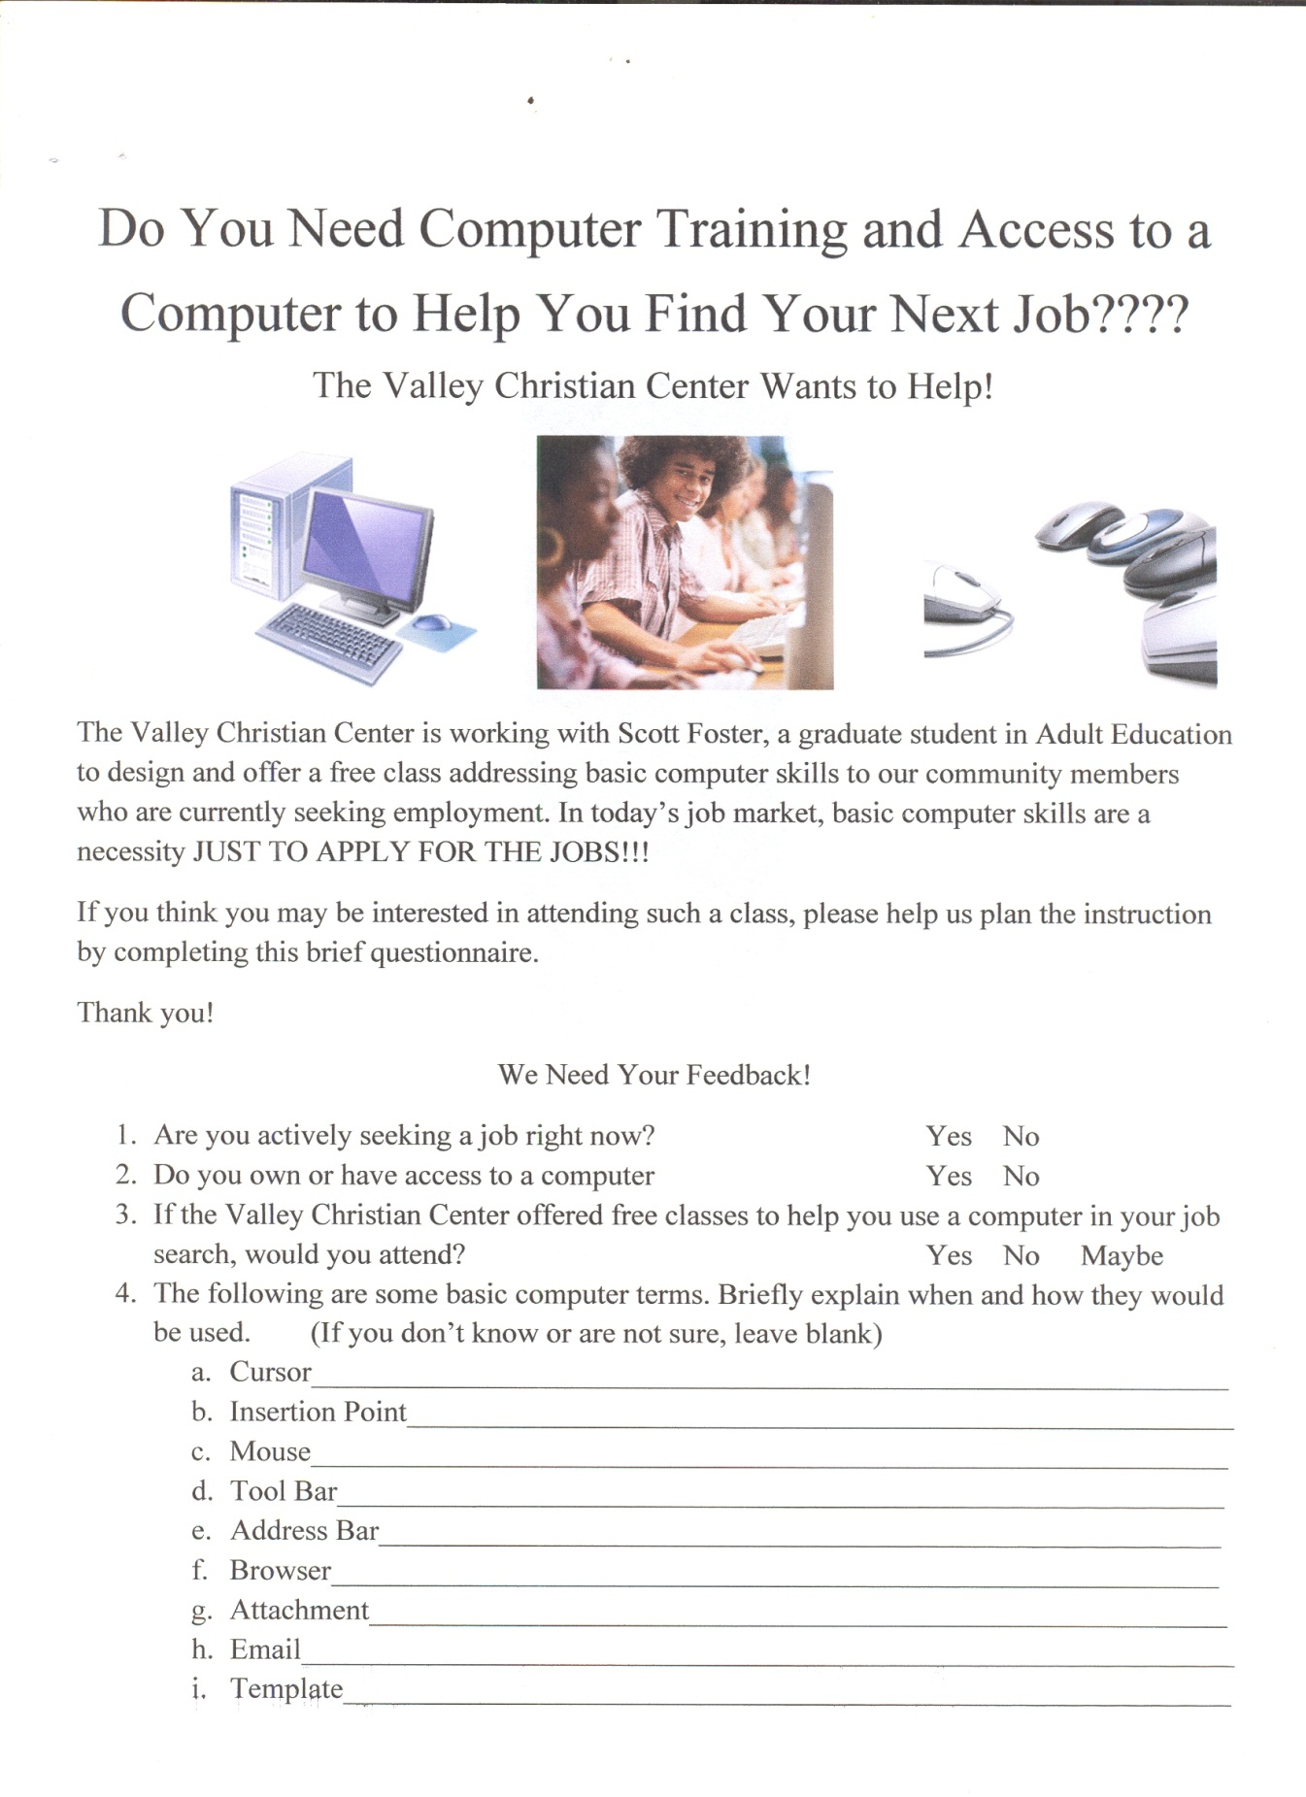
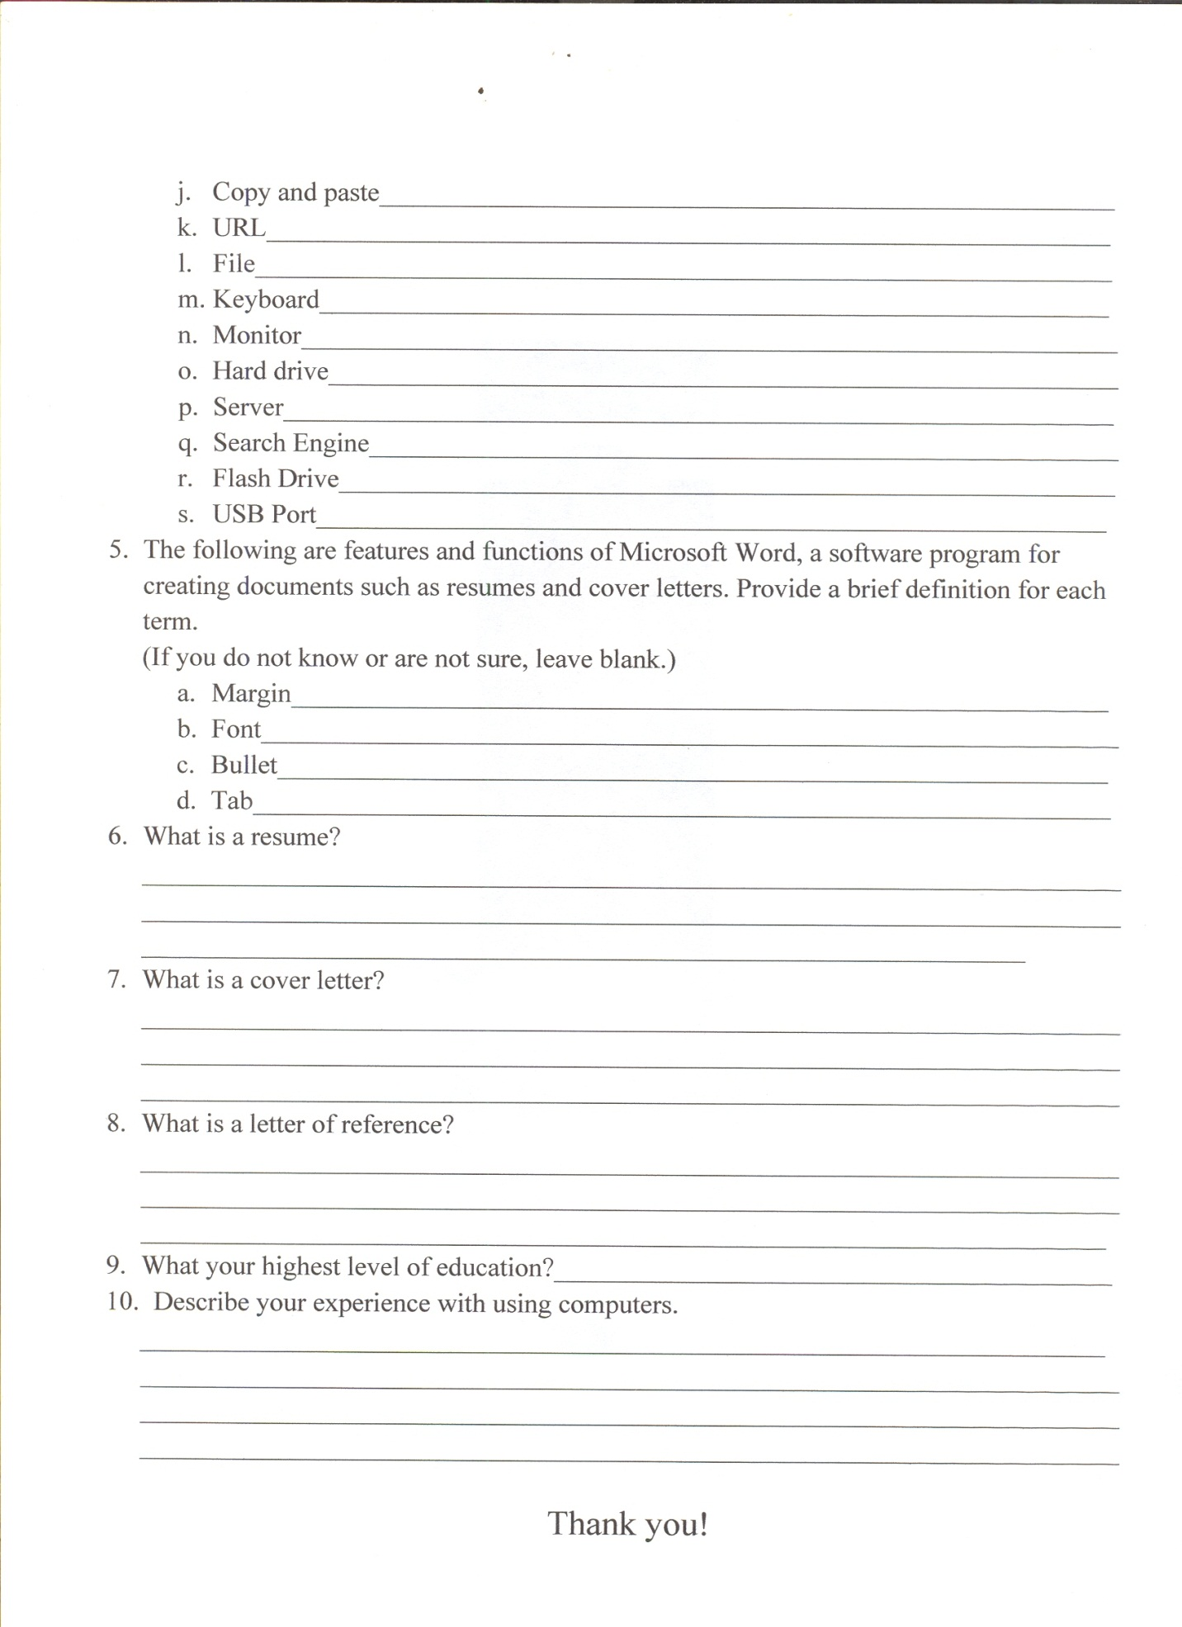
Appendix C
Learning Assessments

These objectives and learning assessments are for a three-session free course addressing Basic Computer Skills for Today’s Job Seekers at the Valley Christian Center, a local faith-based charity organization. The course will consist of a session on Basic Computer Literacy, a session on creating MS Word Documents, and a Final Review/Wrap Up/Q & A Session where participants can polish and practice the skills they learned in the first session. The course will be taught face to face at the computer lab at the Valley Christian Center.

Primary Objective #1
At the conclusion of this course, the participant should be able to identify and explain key MS Windows-based computer terminology and functions used when conducting an online employment search.
Learning Assessment
The assessment for this objective will entail completing a two-part written test at the end of the first half of the session on Computer Literacy. The first section of the test will ask the participants to identify computer terms by presenting a combination of pictures, diagrams, and screen shots with arrows pointing to key features and a random list of the terms. Participants will match the terms to the arrow. For the second half of the test, students will match a list of definitions and functions to the terms themselves.

Rationale for Assessment Method
This assessment method was chosen based on the type of learning associated with this objective (declarative knowledge) and the “typical” learners who will be participating in the class (having little or no experience using computers and limited formal education). The instruction provided will be highly rudimentary and only cover the basic information needed to use a computer to conduct a job search and complete online applications. To best facilitate learning within these parameters, the simple approach is the best approach. By providing the terms, the definitions, and the functions, and having the students correctly align the alternatives through matching and fill-in-the-blanks exercises, this assessment will not only measure their learning to that point, but also reinforce their learning through review and summarization before moving on to the next activity where they’ll apply their new knowledge. Once this assessment is completed, the information will again be reviewed in class by going over the correct answers.
Primary Objective #2
At the conclusion of this course, the participant will be able to demonstrate the correct application of those computer functions used to integrate internet based resources into their job search.
Learning Assessment
This assessment will be conducted at the end of the second half of the Computer Literacy Session and require the participants to demonstrate their ability to access and navigate the internet, locate and utilize key job search boards, and complete online job applications. Specifically, they will be asked to print “search” page samples from three different online job boards for a specific job category, and complete and print an online job application
Rationale for Assessment Method
Because the class will be conducted face to face in a computer lab, students will have the opportunity to apply their new computer knowledge hands on (providing a foundation for future experiential learning) and easily demonstrate that knowledge by completing the assessment activity. If they understood what they learned, they’ll be able to easily show it with this assessment. If they can’t complete the assessment due to a lack of understanding, the deficiency can be easily remedied by more hands-on, one-on-one help from the instructor. They will learn by doing, which is one of the best ways to learn.
Primary Objective #3
At the conclusion of this course, the participants should be able to utilize email in their job search.
Learning Assessment
This learning assessment will be given at the end of the second session on Computer Literacy. Participants will be asked to compose and forward an email with attachments to the instructor.
Rationale for Assessment Method
The rationale for this assessment is virtually the same as with Objective #2 – Because of the learning environment (a computer lab), the participants can practice their new skills and knowledge and apply them hands on without delay, or get the additional instruction if needed. By practicing the skills they’ve just learned, the learning is further reinforced.

Primary Objective #4
At the conclusion of this course, the participants will be able to apply MS Word software to create documents used in job searches such as resumes, cover letters, employment history data sheets, and follow up correspondence.
Learning Assessment
Participants will create and present hard copy examples of their resume, cover letter, employment history data and follow up letter. Due to time restrictions, this assessment may have to be broken up over two sessions. Participants will have time to create one or two documents at the end of the MS Word Session, then create the other documents during the Final Practice Session.
Rationale for Assessment Method
Again, the lab setting gives us the participants the opportunity to demonstrate hands on application of information learned in class. They will have concrete results – the job search documents necessary to find and secure employment. Being able to present these documents to the instructor is proof of the learning. The instructor can also provide any feedback to improve their understanding instantly.
Primary Objective #5
At the conclusion of this course, the participants should be able to access, modify, and save electronic copies of their job search documents on a portable flash drive.

Learning Assessment
At the conclusion of the course, the participants will present their flash drives with saved documents to the instructor for mutual viewing on the instructor’s computer.
Rationale for Assessment Method
By presenting their flash drive for mutual review with the instructor, the participants will be able to demonstrate that they’ve mastered the use of this tool. For any participants who are still struggling with using a flash drive, further one-on-one instruction will be available.

Appendix D
Content Outline
Basic Computer Skills for Today’s Job Seekers at the Valley Christian Center
This course will be delivered face to face over three sessions of three hours each at the Valley Christian Center Computer Lab utilizing a computer projector. Each participant will use a personal computer at the center to follow along with the instruction. The class breaks down as follows:
Session # 1 – Basic Computer Literacy
Learning Objective #1
At the conclusion of this course, the participants will be able to identify and explain key MS Windows-based computer terminology and functions used when conducting an online employment search.
Learning Activity
The instructor will present a PowerPoint presentation providing detailed screenshots explaining key terminology related to personal computer functionality. The presentation will cover basic hardware including the monitor, tower, keyboard, and mouse. Other terms addressed in this session will include power button, desktop, window, icon, start button, start menu, program button, off button, program menu, minimize button, maximize button, close button, search engine, title bar, browser, address bar, tool bar, scroll bar, and task bar.

Assessment
Following the learning activity, the participants will be given a Terminology Quiz. Using various screenshots and diagrams, they will be asked to fill in the blanks identifying the terms discussed and the definition of those terms. After the participants have completed the quiz, the answers will be reviewed and discussed, further reinforcing the learning.
Learning Objective #2
At the conclusion of the course, the participant should be able to demonstrate the correct application of those computer functions used to intergrade internet based resources into their job search.
Learning Activity
Using the projector to demonstrate the correct application of accessing and utilizing the internet, students will follow along with the instructor accessing various websites including job boards and job application screens for various employers. Instructor will go around and check with each student to ensure that they are following the instructor’s lead.
Assessment
Following the learning activity, the participants will do the second assessment. This assessment will ask them to shut down their computers correctly, then restart and access Internet Explorer. They will then be asked to locate three specified Job Board websites, search the site for restaurant jobs, and print the search results. They will then be asked to find the website of an employer they are interested in working for and filling out and printing an online job application for that employer.
Learning Objective #3
At the conclusion of the course, the participants should be able to utilize email in their job search.
Learning Activity
Using the projector to demonstrate, the instructor and students will create a gmail account. The participants will provide their username to the instructor who will post a list of all participants email identifiers. Participants will then write and send one email to each member of the class.
Assessment
Following the learning activity, each participant will create and send an email to the instructor telling him what they learned today.
Session #2 – Using MS Word to Create Documents
Learning Objective #4
At the conclusion of the course the participants will be able to apply MS Word software to create documents used in job searches such as resumes, cover letters, employment history data sheets, and follow up correspondence.
Learning Activity
Utilizing a PowerPoint presentation, the instructor will cover basic functions used in Microsoft Word when creating resumes and other documents. Participants will then be given sample templates for employment history data sheets, resumes, cover letters, and follow up letters and be asked to create their own versions of these documents for use in their job search.
Assessment
Participants will be asked to forward electronic copies of their employment data sheets, resumes, cover letters, and follow up letters to the instructor as email attachments.
Learning Objective #5
At the conclusion of this course, the participants should be able to access, modify, and save electronic copies of their job search documents on a portable flash drive.
Learning Activity
Using a brief lecture format and the projector, the instructor will demonstrate the correct way to save documents onto a portable flash drive.
Assessment
Students will save their documents onto a flash drive, correctly remove the flash drive from their computer and present the drive to the instructor to reinstall onto his computer and review the saved files.
Session #3 – Review and Practice Session
Learning Activity
This session will be reserved for any one on one instruction necessary to reinforce the concepts learned and to provide assistance with completion of the participants’ employment documents as needed. The one on one instruction will be handled on an as needed, case by case basis.

Appendix E
Formative and Summative Evaluations
Basic Computer Skills for Today’s Job Seekers at the Valley Christian Center
Two important elements of the instructional design process are the Formative Evaluation and Summative Evaluation. The application of each can be somewhat variable depending on the nature and scope of the learning event, intended audience, context, and other factors. Both are conducted to measure the effectiveness of the instruction by gathering pertinent feedback, considering potential adaptations, then using that information to fine-tune the learning event with respect to what is taught and how it is taught in order to maximize the overall effectiveness of the program or course. The stake holders play a major role in both processes.
Stake Holders
The stake holders for this course include the following people:
- The learners – job seekers lacking basic computer skills living in the immediate proximity of and utilizing the social services of the Valley Christian Center.
- Becky Castro, Director of the Valley Christian Center who is attempting to revitalize the facility by offering a greater variety of services to its customers, thus enhancing its marketability to investors and charitable contributors so that the Center can more effectively achieve its organizational goals as a faith-based charity.
- Board of Directors for Valley Christian Center who are dedicated to promoting the institutional health and interests of the organization and the welfare of the people it serves.
These stake holders will be utilized for the Formative and Summative Evaluations by participating in a review of the materials and/or actual instruction and providing constructive feedback through surveys designed to measure the accuracy and effectiveness of the learning content and the overall course.
Formative Evaluation
The Formative Evaluation is typically conducted during the course development process and may also be incorporated into the actual learning event or events. The Formative Evaluation analyzes the effectiveness and accuracy of the teaching materials and course content as it relates to the learning objectives. From the learner’s perspective, does the course effectively teach what it intends to teach? Is the presentation logical? Is the instruction understandable? What, if anything, needs to be adjusted, altered, deleted, or added to make it more effective? Does the instructional design effectively facilitate the learning process? The Formative Evaluation is used to “fine tune” the learning materials and delivery content to maximize the course effectiveness. It focuses on how the course is taught.
The parameters of my instructional design project, a free computer course for people with limited skills being offered through a charity-based organization, pose some challenges when conducting the Formative Evaluation. Nobody is getting compensated to create or teach the course, and nobody is paying to attend the course or required to attend. Therefore, my ability to gather extensive data for the Formative Evaluation is somewhat limited. For instance, it is not practical to test the instruction prior to offering the class. Any participation in the process by others is dictated by how much time they are willing to volunteer for the good of the project. As with any group endeavor the dynamics are much different in a scenario where people participate strictly on a voluntary basis.
I am conducting my Formative Review in multiple phases. During the Development process I have been copying my Course Objectives, Learning Assessments, and Content Outline with both my classmates and course instructor in EDAE 629 and with Becky Castro, Director at the Valley Christian Center for their informal input. Prior to teaching the course for the first time, I will share all my learning content, syllabus, and assessment instruments with the Board of Directors at the Valley Christian Center as well. One of the goals of this course is to draw people back to the VCC to utilize their computer lab and generate more interest in other activities at the center. So, the Board members are stakeholders in the course indirectly, and as such, will hopefully be willing to donate some of their time to assist with the Formative Evaluation. Each board member will be given a Formative Evaluation survey to partially complete (see Appendix A, Part A only). Each will also be invited to attend and participate in the initial learning session.
The course is planned over three sessions. At the conclusion of each session, the participants will also be asked to complete the survey measuring the effectiveness of the instruction (see Appendix A – Part A & B). In addition, I intend to videotape the learning sessions and using it to further conduct an additional analysis as part of the Formative Evaluation Process.
The results of the Formative Evaluation will then be used to make any necessary corrections to the learning content in terms of accuracy and completeness. Depending on the feedback gathered in the evaluation, additional material may be added for clarity, material may be changed, additional exercises provided, and environmental factors may be altered if any
issues are identified.
Summative Evaluation
The Summative Evaluation analyzes how successfully the instruction “fills the educational gap” that it was created to fill. It’s a big-picture perspective of the success of the course in terms of favorable learning outcomes. The Summative Evaluation is used to incorporate revisions into the overall course to better meet the broad course objectives. It focuses on what the course teaches, when the course is taught, and whether the students consider the course successful enough to recommend to another friend.
I will present the Summative Evaluation (Appendix B) for my course at its conclusion. Participants will be asked to answer the questions to provide reflection of the overall effectiveness of the course. Those comments will then be used to make necessary changes to future classes with regards to when, where, and what is presented.

Appendix A – Formative Evaluation
Basic Computer Skills for Job Seekers at the Valley Christian Center
Part A – Written Material, PowerPoints, Handouts, Assessments
Instructions – Please answer the following questions about the class you attended today and elaborate in your own words in the space provided. Use extra sheets of paper if needed. Do not provide your name. Thank you.
- Were the written materials accurate, error-free, easy to understand, and use? Yes No Somewhat
_________________________________________________________________
_________________________________________________________________
_________________________________________________________________
_________________________________________________________________

- Was all terminology thoroughly explained? Yes No Somewhat
____________________________________________________________________________________________________________________________________________________________________________________________________________________________________________________________________

- Were the computer functions adequately explained? Yes No Somewhat
____________________________________________________________________________________________________________________________________________________________________________________________________________________________________________________________________

- Were the assessments helpful in reinforcing your understanding of the material? Yes No Somewhat
____________________________________________________________________________________________________________________________________________________________________________________________________________________________________________________________________
- Was the syllabus clear, understandable, and accurate? Yes No Somewhat
____________________________________________________________________________________________________________________________________________________________________________________________________________________________________________________________________
- Did the course content enhance your understanding of personal computers? Yes No Somewhat
____________________________________________________________________________________________________________________________________________________________________________________________________________________________________________________________________

Part B – Instructor, Computer Lab, Course Times

- Was the instructor easy to understand? Yes No Somewhat
____________________________________________________________________________________________________________________________________________________________________________________________________________________________________________________________________
- Was enough there enough time in the session to adequately cover the material? Yes No Somewhat
____________________________________________________________________________________________________________________________________________________________________________________________________________________________________________________________________

- Was the computer lab a favorable environment to learn the material? Yes No Somewhat
____________________________________________________________________________________________________________________________________________________________________________________________________________________________________________________________________
- Did you experience any technical issues with the equipment provided? Yes No Somewhat
____________________________________________________________________________________________________________________________________________________________________________________________________________________________________________________________________
- Were the location and class time(s) convenient for you to attend? Yes No Somewhat
____________________________________________________________________________________________________________________________________________________________________________________________________________________________________________________________________
- Do you have any additional suggestions on how the class can be better taught? Yes No
_____________________________________________________________________________________________________________________________________________________________________________________________________________________________________________________________________________________________________________________________________________________________________________________________________________________________________________________________________________________________________________________________________________________________________________________________________________________________________________________________________________________________________________________________________________________________________________________________________________________________________________________________________________
Appendix B – Summative Evaluation
Basic Computer Skills for Job Seekers at the Valley Christian Center
Instructions: Please respond to the following questions about the course you just completed.
- Did you learn the terminology and computer functions necessary to conduct an online job search and complete online employment applications?
________________________________________________________________________________________________________________________________________________________________________________________________________________________________________________________________________________________________________________________________________________________________________
- Do you have an adequate understanding now of Microsoft Word and are you able to use it to create a resume, employment history data sheet, and employment correspondence?
________________________________________________________________________________________________________________________________________________________________________________________________________________________________________________________________________________________________________________________________________________________________________
- Can you comfortably access and use your new email account?
________________________________________________________________________________________________________________________________________________________________________________________________________________________________________________________________________________________________________________________________________________________________________
- If the course is offered again, what should be done differently?
________________________________________________________________________________________________________________________________________________________________________________________________________________________________________________________________________________________________________________________________________________________________________
- Would you recommend this class to a friend?
________________________________________________________________________________________________________________________________________________________________________________________________________________________________________________________________________________________________________________________________________________________________________

- If given the chance to utilize the Valley Christian Center Computer Lab to conduct your job search, would you take advantage of the opportunity?
____________________________________________________________________________________________________________________________________________________________________________________________________________________________________________________________________________________________________________________________________________________________________

