Safety Training Requirements Ignored:
An Arizona Homebuilding Workforce Education Issue

Scott Foster

Colorado State University

EDAE 601

Doctor Foley

July 24, 2010

Abstract:

Thus far in our studies, we have often viewed the concept of workforce education in terms of potential and realized benefits for employees and employers. For employees and potential employees, it empowers them with the means to acquire the knowledge and skills required to cultivate successful careers. For employers, it provides trained and competent workers that facilitate successful businesses. In some cases, such as adequate worker safety training, workforce education is also not just a potential benefit, but also an ethical responsibility for both. In the homebuilding business in Phoenix, Arizona, that responsibility is not always adequately addressed and the result can be catastrophic.
Construction work, including residential construction is inherently dangerous. Thousands of workers each year are needlessly injured on the job and some even die trying to make a living in the business. Occupational Safety and Health Administration (OSHA) regulations require employers to train their employees to recognize potential hazards in their work environments and understand the OSHA regulations necessary to maintain a safe work environment. For a variety of reasons, those training requirements are sometimes ignored and workers are left vulnerable to physical injury and job related illness as a result.
This paper will address this critically important workforce education issue; the physical, emotional, ethical, economic, and legal ramifications this issue poses for employees and employers; and possible solutions to resolve the issue, taking into account the reasons why some employers wish to maintain the status quo.

Safety Training Requirements Ignored:
An Arizona Homebuilding Workforce Education Issue

“The employer shall instruct each employee in the recognition and avoidance of unsafe conditions and the regulations applicable to his work environment to control or eliminate any hazards or other exposure to illness or injury.”
CFR 1926.21(b)(2), OSHA Standards for the Construction Industry

As we’ve discussed in class, the term workforce education can have broad context such as introductory programs offered within secondary schools and post-secondary educational institutions. It can also be applied to more advanced, occupation-specific training found in higher learning institutions, technical schools, business, and industry. One aspect of workforce education core training relevant to most occupations is safety training. For occupations such as construction, including residential construction, such training has implications that go far beyond necessary skills and job knowledge. These implications go beyond performing tasks more efficiently, functioning more economically, or producing more competitively. They go beyond company profitability and market share. For those who work in construction, safety training, or the lack thereof, can have life changing, lifesaving, and even life ending consequences. Every year workers lacking adequate safety training unnecessarily sustain injuries, lose limbs and sometimes their lives while on the job.
What makes construction work so dangerous? There are a number of factors contributing to the situation. Some of these factors include:
- Construction workers often work unsupported and unrestrained at heights on ladders and leading edges such as unfinished floors and roofs, making them susceptible to falls. Each year, falls consistently account for the greatest number of fatalities in the construction industry (OSHA Worker Safety Pocket Guide).
- They use and/or work close to others that use potentially dangerous tools such as power saws and drills, pneumatic nail guns, jack hammers and other cutting, drilling and fastening tools. These tools are intended to be used on wood, concrete, and other hard materials, but sometimes contact human flesh.
- Construction workers are subject to potential electrical shock due to the use of temporary power sources and portable generators that may not be properly grounded and extension cords that are damaged or frayed. “The human body is composed of approximately 80% water and is a great conductor of electricity (Tompkins 2009).” Electricity is another leading killer on construction sites.
- Construction work requires the staging and temporary storage of materials that are heavy and sometimes unstable. To place and relocate these materials, heavy equipment such as tractors, cranes, and forklifts are often in use on the jobsite incorrectly resulting in serious injuries.
- In addition, it is common to see different tradesmen from different industries and companies working in close proximity to one another on the residential construction site. This concentration of workers often leads to potential accidents because of the degree of independent, potentially dangerous activity going on simultaneously.
- Other safety factors inherent to construction work are too numerous to list. Any time anybody walks onto an active construction site, their risk of injury increases.
U.S. Bureau of Labor Statistics for 2008, the most recent data available, indicate that more fatalities occurred in construction than any other occupation - 975 out of 5,214 total fatal work injuries for the year (See Appendix A). That’s a national average of 2.7 deaths per day. Countless other workers sustain non-fatal injuries each day. The dangers cannot be ignored, yet that’s exactly what some employers do in residential construction when they do not provide safety training to their employees. Those employees have the legal right to force the issue, but often choose not to do so.
The Issues
From 2004 to 2008 I held the position of Director of Education and Safety for the Home Builders Association of Central Arizona. In that capacity I often discussed safety and safety training with numerous builders and residential contractors. In the course of those conversations, I became acutely aware on a first hand basis of the disparity that exists within the industry in Phoenix with regard to safety training.
I found that many builders and residential contractors meet and/or exceed the minimum safety training requirement. Many engage in internal training regularly, and attend and pay their employees to attend outside safety classes as well. They conduct their own “tailgate talks” in the field addressing a variety of safety topics on an ongoing basis. Perhaps most importantly, they document all training per the requirements. Those employers are committed to safety training as a vital component of their ongoing workforce education programs. They also realize that safety is not only the right thing to do, it is good for business.
Other residential contractors and builders are either uninformed of their responsibilities under the Occupational Safety and Health (OSH) Act, or are aware of their responsibilities and choose to ignore them. There are many reasons given by those employers for not complying. During the busy times just a few years ago when Phoenix and Atlanta sparred for billing as the top housing market in the country, they were “too busy” to spend time on safety training. Now, during these slower times many of these same companies are “watching their money” and citing company economic survival as a priority over safety training and worker survival. Yet others view the OSHA requirements as an example of governmental bureaucracy meddling in the affairs of free enterprise and view the training requirements as excessive and unreasonable, so they choose not to participate. With people’s lives and health at stake, this reasoning and lack of regard for worker safety is arguably reprehensible from a moral and ethical point of view.
Employers not only have a moral and ethical obligation to train their employees how to do their jobs safely. They also have a legal obligation. Under OSHA law, employers have the responsibility to train their employees to recognize and avoid known hazards and provide a jobsite that is safe. Likewise, employees are tasked with the responsibilities under OSHA law. Those responsibilities include notifying their employer of unsafe conditions and notifying OSHA if the employer does not correct those conditions. In this sense, both employers and employees are stakeholders by law in the safety training process.
In Arizona and 25 other states plus Puerto Rico and the U.S. Virgin Islands, the jurisdiction for enforcement of OSHA laws lies at the state, not federal level. Under the provisions of the OSH Act, states can apply and be granted the right to act on their own to control and manage jobsite safety, provided they apply worker safety laws at least as stringently as Fed OSHA. The Arizona Department of Occupational Safety and Health (ADOSH) is tasked with that responsibility in my state. Unfortunately, the agency has always lacked sufficient funding to provide comprehensive oversight to jobsite safety in the residential construction sector. Unless a jobsite fatality or catastrophe (an incident causing the hospitalization of three or more people) occurs, ADOSH rarely visits residential jobsites. Now, the state of Arizona’s budget crisis is affecting ADOSH’s ability to enforce jobsite safety laws even more than before, due to a statewide hiring freeze and the loss of inspectors due to attrition and retirement. Consequently, the enforcement of safety training laws is seldom realized. More than any other factor, this contributes to the current safety training disparity amongst contractors in the home building business in Arizona.
Industry Ramifications Relevant to the Safety Training Issue
Physical and Emotional Ramifications
The ramifications of this workforce education issue are potentially far reaching on many levels for both employers and employees. Employees lacking proper safety training are at greater risk for injury. They often lack the necessary awareness to successfully identify potential hazards, and as a result unknowingly make themselves vulnerable to those hazards. It is important to point out that employees need not only a healthy awareness of how to act safely when performing their jobs, but also have knowledge about the nature and safety aspects of other people and other trades working in the same vicinity. Residential contractors often work side by side simultaneously. See Appendix B for a prime example of what can happen.
In human terms, the ramifications for the employee can be injury and even death. For the employee, there is great potential pain and suffering. For the families of employees that are injured or killed on the job, the lack of safety training can have incalculable consequences in terms of hardship and heartbreak. These results cannot truly be measured in terms of money. How much does losing a leg really cost someone? What is a human life worth? These are the most tragic consequences of failing to train workers to be safe on the job.
Economic Ramifications
On an economic level, a lack of adequate employee safety training has potential detrimental consequences for both employee and employer. For the employer, they can be fined by ADOSH if they cannot produce documentation of their safety training when asked. Granted, the chances of getting caught seem to favor those who do not comply, but if a serious accident or fatality were to occur on their jobsite, an investigation by ADOSH would be conducted and failure to provide documentation as evidence of training could lead to the assessment of fines in the thousands of dollars. OSHA classifies fines based on circumstances as follows:
- Other than Serious – defined as violation with dire relationship to job safety and health that is not likely to cause death or serious harm. Potential fine – up to $7,000.
- Serious – defined as violation with substantial probability that death or serious physical harm could result. The employer knew or should have known of hazard. Fine – mandatory penalty of up to $7000.
- Willful – defined as a violation committed with plain indifference to the law. Fine – penalties are a minimum of $5,000 and maximum of $70,000. The employer is subject to fines and/or imprisonment.
The penalties can be severe, but unless something happens, the risk of getting caught is relatively low, so companies take their chances rather than just taking the time to follow the law and implement safety training prior to allowing the employees to work.
Along with fines, employers potentially pay in other ways for failing to conduct adequate safety training. Should their employees sustain injuries on the job requiring the filing of workman’s compensation claims, their insurance premiums can increase dramatically. In addition, their workman’s compensation insurance carriers could require them to conduct training as a policy condition. Lastly, the workman’s compensation insurance industry assigns an experience modifier number to companies based on past history of claims and payouts. As part of their risk management strategies, many builders/general contractors will not allow subcontractors with high numbers to bid their work. Limits placed on the ability to bid limits incomes as well. For these reasons, insurance premiums are as effective if not more effective as potential OSHA fines when it comes to motivating businesses to provide the safety training that their employees need and are entitled to receive.
When employees are injured, they too pay an economic price. Even though workman’s compensation insurance is mandatory, there are limits to the benefits paid. Long term injury or death exacts an economic price on the victim that is often irreversible.
Lastly, for employers there is potential penalty through litigation. Should the issue of injury sustained due to a lack of safety training become a lawsuit, legal fees and/or jury awards can bankrupt the employer.
Legal Ramifications
Along with the potential for civil action, employers who knowingly allow employees to work in dangerous conditions, such as working without the proper safety training, can sometimes face criminal charges and possible imprisonment for their actions should someone die on the job. This law can be applied to not only the owner of a business, but the field supervisors as well. For example, should a fatality occur on a construction site, if it can be proven that the victim’s supervisor had prior knowledge of the dangerous condition that led to the fatality, that supervisor can be charged with criminal negligence and face possible incarceration. Such a high degree of responsibility is sobering, yet most field supervisors in the home building business are unaware of their potential liability.
Addressing the Issue
Resolving the issue of employers failing to properly provide safety instruction to their employees is a daunting challenge. It is already against the law, yet due to weak enforcement on the part of ADOSH primarily due to a shortage of resources, the problem persists. However, there are options available depending on one’s position and sphere of influence.
For employees, OSHA law is quite clear. They not only have the right but the legal obligation to bring potentially hazardous jobsite conditions, including lack of proper safety training, to the attention of their employer for correction. Furthermore, if their employers do not act to correct the issue(s) they are required to notify OSHA, or in Arizona’s case, ADOSH directly to get them involved. Employees are protected by law from retribution by the employer for taking such action. Despite this, few employees take such action. For many, they are unaware of their rights because they lack proper training in safety and OSHA regulations. Those who are aware remain fearful of their jobs in spite of the laws.
An added dimension to this situation is the number of legal and illegal immigrants utilized in the construction industry. According to a study conducted by the Pew Hispanic Center in 2008, foreign born Hispanic workers made up 43.3% of the construction workforce in Arizona as of 2006. From a cultural standpoint, these people lack a “safety culture” mindset, value the relatively high wages they can earn in construction, and are therefore reluctant to make an issue out of their employers’ failure to train them in safety. For those who are here illegally, there is a constant fear of discovery and deportation so they are even more reluctant to raise the issue.
Having cited all the reasons why employees seldom raise the issue, the fact remains – they do have the legal right and obligation to force their employers to comply. For those with the courage, this is one way to address the issue.
For industry safety managers, training managers, other managers and field supervisors, the direct answer to the problem is insistence that employers comply with the law. For those with this sphere of influence looking for a diplomatic approach to the problem, the primary options available to them is persuasive argument, citing all the reasons mentioned in this paper.
Additionally, as a training manager for a builder or subcontractor, one can perform an analysis of the typical jobsite hazards and tailor an original program to those conditions, or become authorized to teach and conduct the OSHA Outreach 10 hour Construction Safety Class. That class, which falls under the OSHA Outreach Program, was specifically designed and created to help facilitate employer safety training in the construction industry. It establishes consistent training standards that cover the most common injuries and includes minimum trainer requirements that are attainable without advanced certifications or degrees. Those who complete the program receive a card from OSHA. The program is designed to proliferate safety training and make it convenient and affordable. For some in construction, the 10 Hour OSHA Class, as it’s commonly called, provides some of the basic training, but not all. They may require additional training as well. However, for most construction employers and employees, the 10 OSHA Class does provide adequate minimum safety training to comply with the requirements.
For industry advocates, such as trade associations and lobbyist organizations, the issue of employer safety training can be handled in a similar fashion. According to Connie Wilhelm, President and Executive Director of the Home Builders Association of Central Arizona (HBACA), the key is to, “work with industries and insurance providers to create a ‘culture of safety’ with companies and industries. It is important that everyone is working to keep safety as a ‘top of mind’ issue. Whenever possible, safety should be emphasized as a key component of workers’ training.”
In addition, organizations such as the HBACA can facilitate employer training by offering discounted OSHA 10 Hour Classes to its membership and design the content of that training to match as closely as possible the home building construction site model. Other things the HBACA does for its membership to promote safety training include providing safety training materials for free or at cost, forming safety committees and conducting regular meetings sharing best practices and training information, and working with ADOSH to host free safety training classes offered by ADOSH. All these measure help make it easier for employers to comply with the requirements voluntarily.
For workers’ rights advocates such as unions and others who wish to force employers to comply, political lobbying for enforcement is another approach to resolving the training issue. Such action in Nevada recently resulted in a new law requiring all construction workers to attend an OSHA 10 Hour Construction Safety Class and all construction supervisors to attend an OSHA 30 Hour Construction Safety Class. Similar laws have been passed in New York and Missouri in recent years. These new laws are really just extensions of the existing OSHA standards regarding safety training, but facilitate enforcement to some degree through standardization of training topics and training documentation proof.
Conclusion
When an aspect of workforce education is required by law but not easily enforceable some companies will choose to be unethical and irresponsible. Such actions are short sighted and dangerous, but companies are run by people, and people are not always inclined to do what is right. So, there will always be some companies who do not train their employees to work safely, and there will always be workers injured needlessly. In a perfect world, it would not happen.
Industry has an ethical and legal responsibility to obey the laws requiring that employers provide adequate safety training to their employees. For all the reasons cited in this paper, safety training and promoting a safety culture are sound business practices as well. Accidents will always happen, even when workers are trained because workers are human and make mistakes. Sometimes accidents occur as a result of worker misconduct. When employers can prove through documentation that workers have received proper training, then later caused themselves or others to be injured through misconduct, those employers are typically relieved of legal liability. Worker safety training is sound risk management in action. Worker safety training is a component of workforce education that is as important if not more so than any other. Worker safety training is the right thing to do.

Appendix A
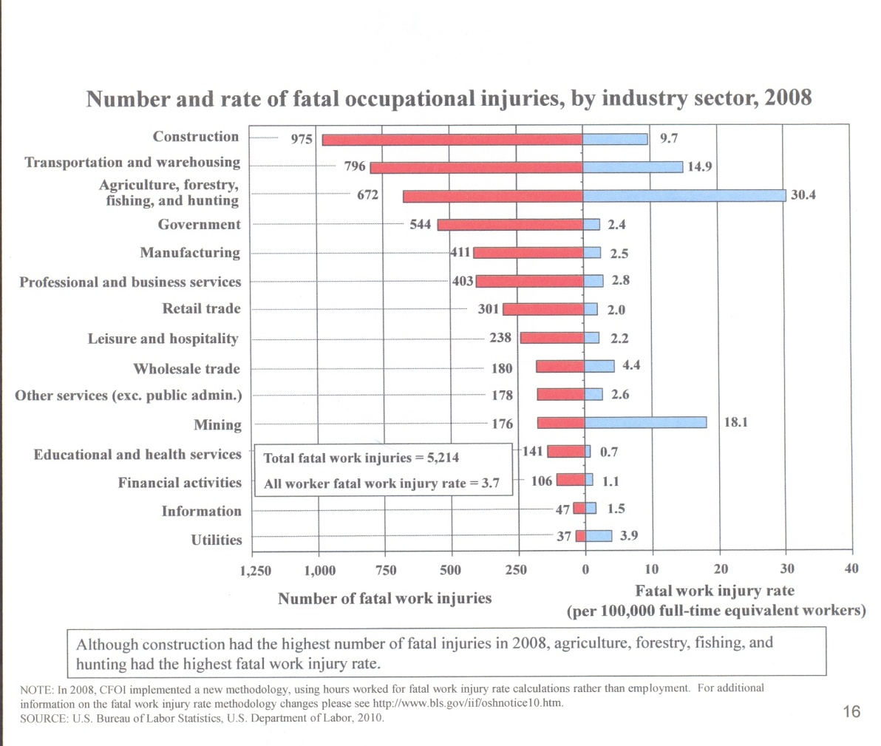

Appendix B

Near Miss on a Residential Jobsite
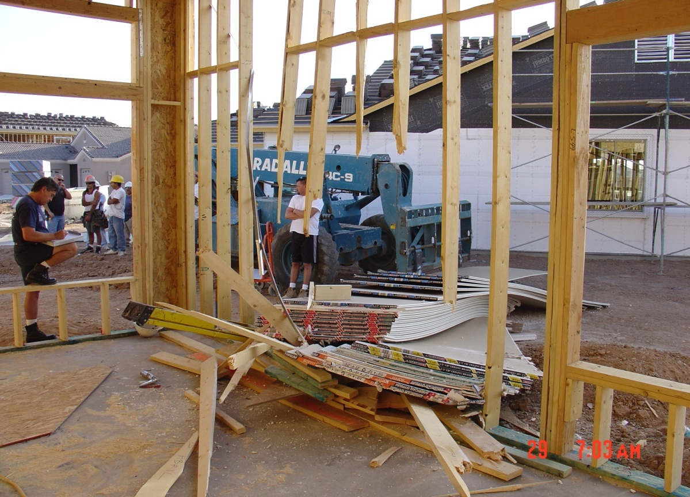
Photo by Shawn Richardson
This photograph shows the aftermath of a construction accident that could have easily caused a fatality. A framer was standing on a step ladder improperly leaned against the outside wall of this home under construction. The forklift operator was delivering a load of sheetrock to the home next door. The load was carried too high off the ground, and the forklift was traveling too fast for safety. As the forklift passed the framer, the load of sheetrock slid off of the skids and crashed into the framer driving him through the framed wall. The sheetrock’s force broke five 2x6 studs in the process. It is estimated that the lost load of sheetrock weighed approximately 1 ½ tons. Had the wall been solid, the framer would have likely been crushed to death. Fortunately, he sustained only minor injuries. Arguably if the framer had been trained to recognize and avoid potential hazards better, and/or the forklift operator had been trained how to properly operate the vehicle better, the situation may have been avoided altogether.

REFERENCES
Pew Hispanic Center, (2008) Arizona – Population and Labor Force Statistics 2000 – 2006 Fact Sheet. Retrieved 7/23/10 from http://pewhispanic.org/files/factsheets/37.pdf
OSHA Fact Sheet – Outreach Training Program, Retrieved 7/23/10 from
http://osha.gov/Publications/OSHA-factsheet-outreach-training.pdf
OSHA Pocket Guide - OSHA 3252-05N 2005, Retrieved 7/24/10 from http://www.osha.gov/Publications/OSHA3252/3252.html
OSHA Standards for the Construction Industry, 1st Edition, 2008
Occupational Safety and Health Administration Website. Retrieved 7/23/10 from www.osha.gov

Tompkins, P. (2008), High Voltage Electric Safety – Safety Precautions on or near High Voltage Power Lines. Retrieved fromhttp://www.gravitymagnet.com/Layout2009/pdf/high-voltage-article.pdf
U.S. Bureau of Labor Statistics. Retrieved 7/24/10 from http://www.bls.gov/iif/oshwc/cfoi/cfch0007.pdf

