Name______________________
Learning Activity #1 Assessment - Terminology Quiz
Match these terms with the blanks.
Icon Monitor Program Menu Task Bar Tower Keyboard
Desktop Search Engine Minimize Button Title Bar Mouse Start Button
Maximize Button Address Bar Program Button Tool Bar Close Button Scroll Bar
Start Menu

2.
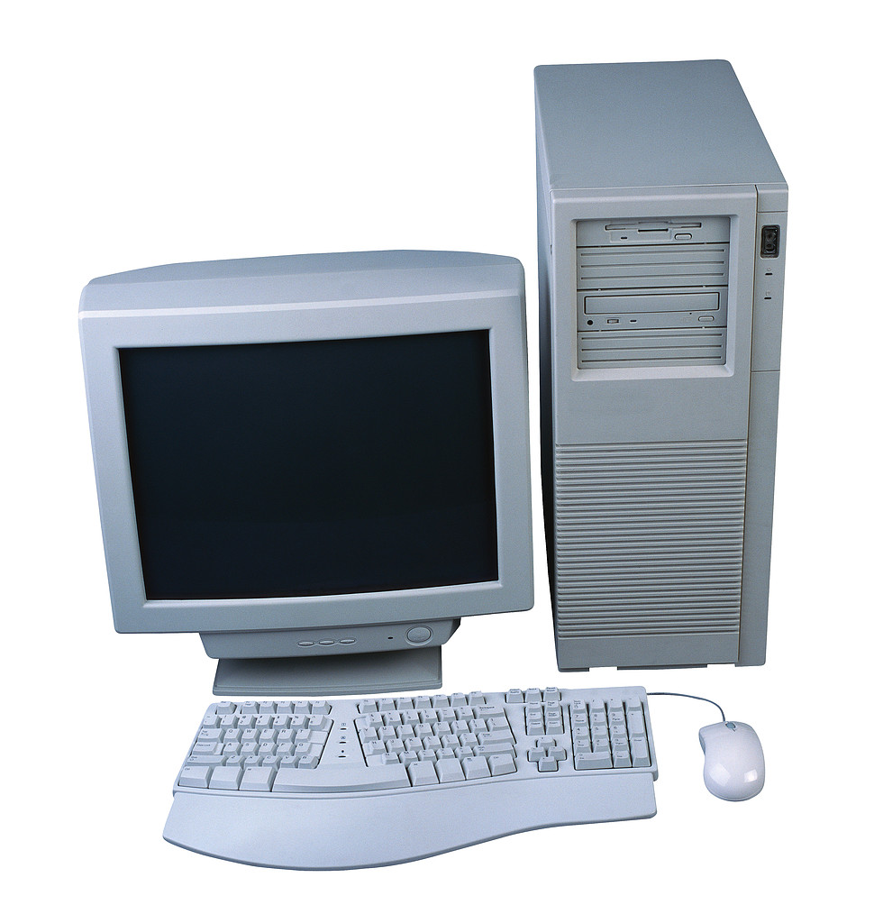
1.
4.
3.
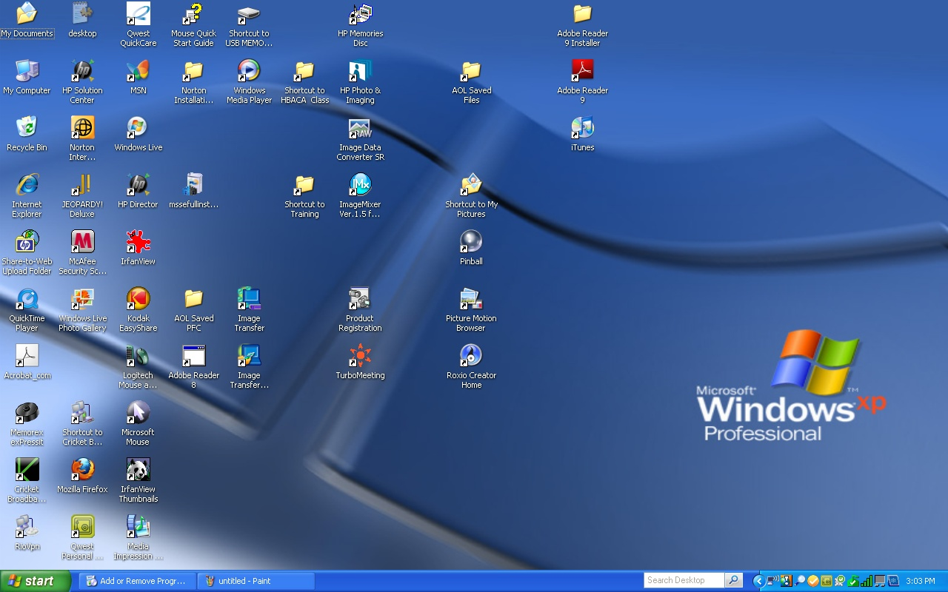
5.
7.
6.______________________

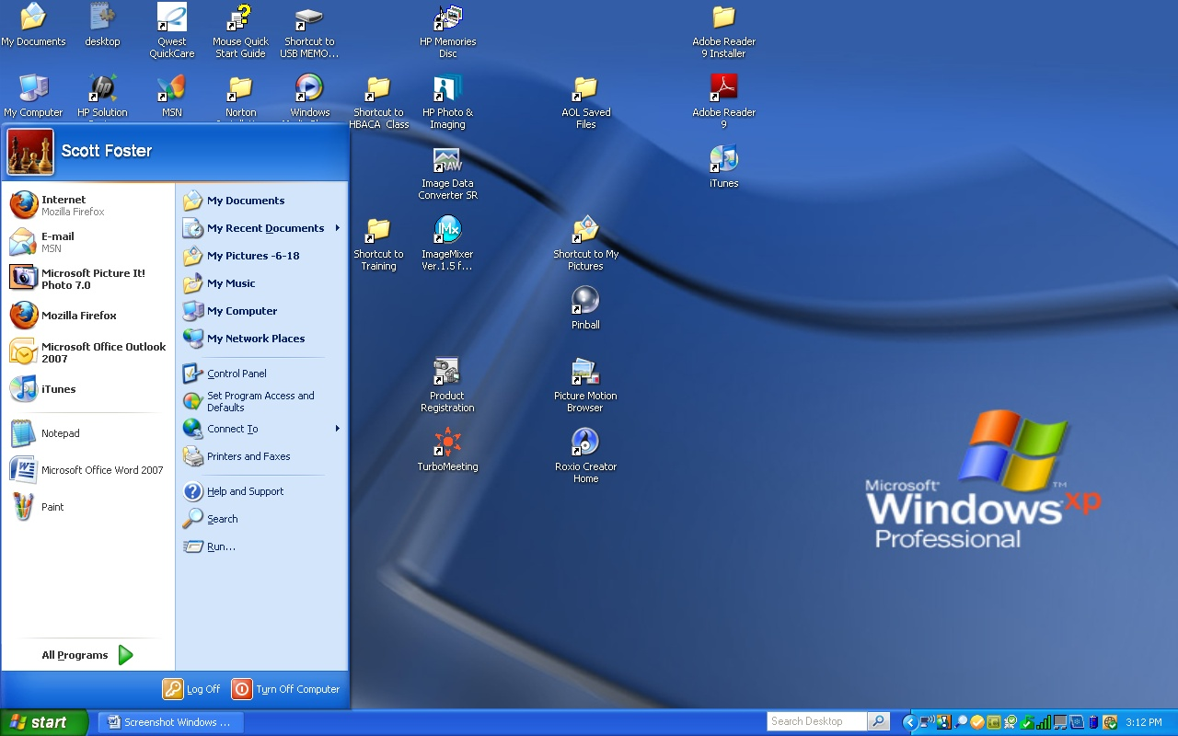
8.
9.
10.

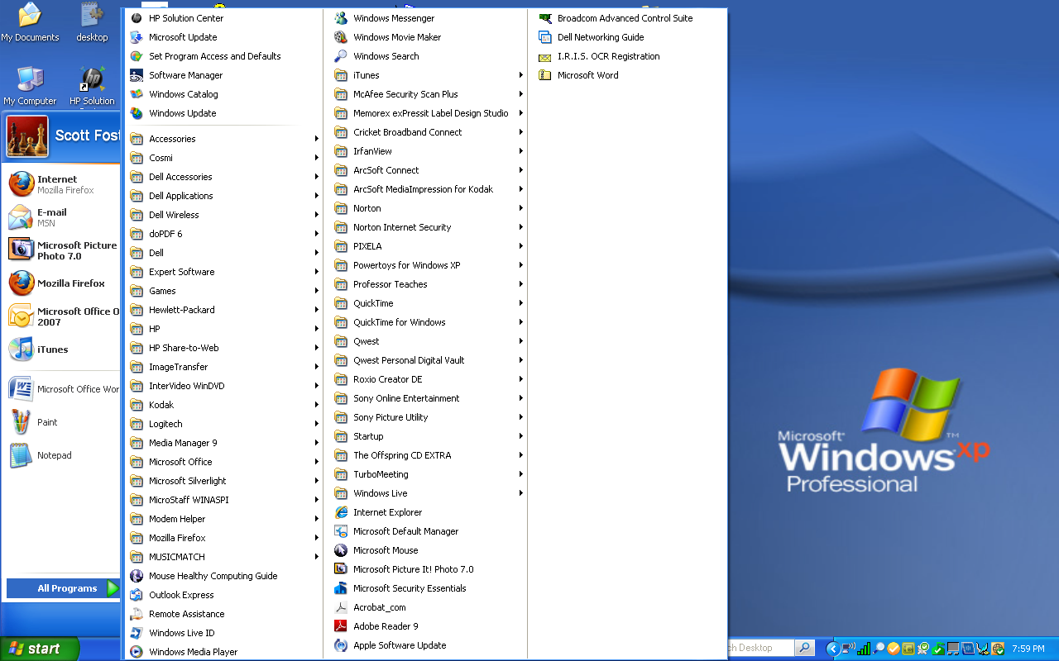
12.
11.

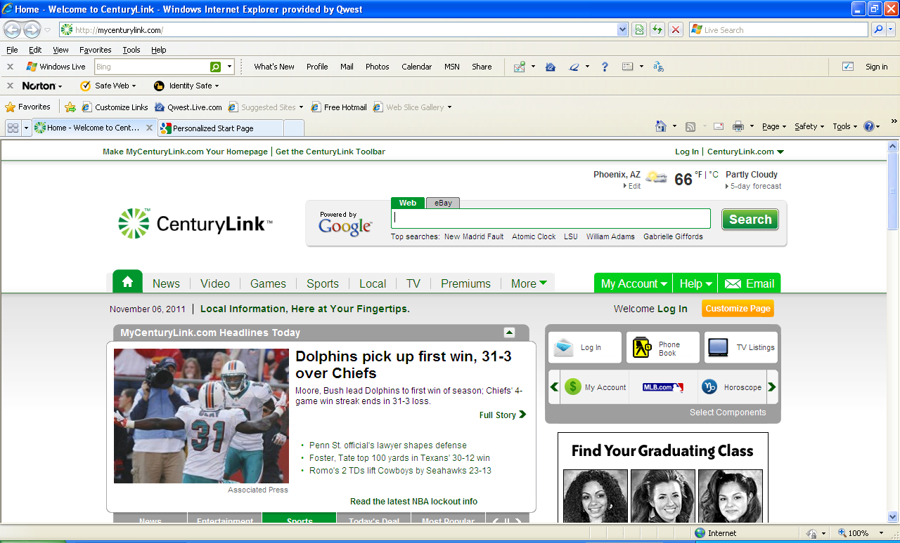
13.__________________

19.
18.
17.
16.
15.
14.

Now match those same terms with these definitions:
A.______________________ - The horizontal bar that sits at the bottom of the screen which displays the titles of all the windows currently open. You can switch to a different window or restore a minimized window by clicking on its title in this bar.

B.__________________________ - An output device with a screen used to show computer images. A video or computer display device.

C.______________________ - Clicking on the Start button opens this menu, which gives you quick access to all installed programs, commonly used folders, and all Windows functions.

D.______________________- This button, the left most in the upper right corner of a window minimizes it, hiding it from view. You can make it reappear by clicking on its entry on the taskbar.

E.______________________ - A small picture on the Desktop representing a file, folder, or program on your computer. Double clicking on an icon will launch the file, folder, or program.

F.______________________ - Input device used to enter letters and numbers into a computer.

G._____________________ - Clicking on the Programs Button opens this menu, which gives you access to all installed programs.

H._____________________ - The main workspace in Windows and the first thing you see when Windows starts. It has a picture (wallpaper or background) that you can customize and icons for opening programs, folders, and documents.

I.______________________ - Box containing the electronic components of a computer that process information and perform tasks.

J.______________________ - Click on this button for a list of all the programs installed on the computer.

K. _____________________ - Clicking on this middle button in the upper right corner or a window makes it fill up your entire screen.

L. _____________________ - Tool used to move the cursor and pointer on the screen.

M._____________________ - Clicking on this button opens the Start Menu.

N. _____________________ - Tool on internet browser window to find and access websites.

O. _____________________ - Tool for moving a window vertically to be able to access and view the entire content of the window.

P. _____________________ - Bar used to identify and locate specific web site addresses.

Q. ____________________ - Button on the far right in the upper part of the screen.

R._____________________ - Area, often horizontal and near the top of the window that contains a number of buttons that can be clicked to perform a specific action.

S._____________________ - Horizontal bar that sits at the top of the screen that identifies the program, folder, or file for the window we are using at the time.

Learning Activity #2 Assessment – Using the Internet

- Shut down your computer.
- Restart your computer.
- Bring up Internet Explorer
- Access the following websites, search for job openings for restaurant jobs, and print your search findings:
  - www.careerbuilder.com ; www.indeed.com; www.jobing.com
- Locate the website of an employer you are interested in and complete the online job application. Print your application.
- Turn into the instructor what you’ve printed.

Learning Activity#3 Assessment – Sending E-mail
Send the instructor an email telling him what you have learned today.

